SUBCOURSE EDITION
OD 0455 6

INTRODUCTION TO SIMPLIFIED TEST EQUIPMENT/
INTERNAL COMBUSTION ENGINES (STE/ICE)



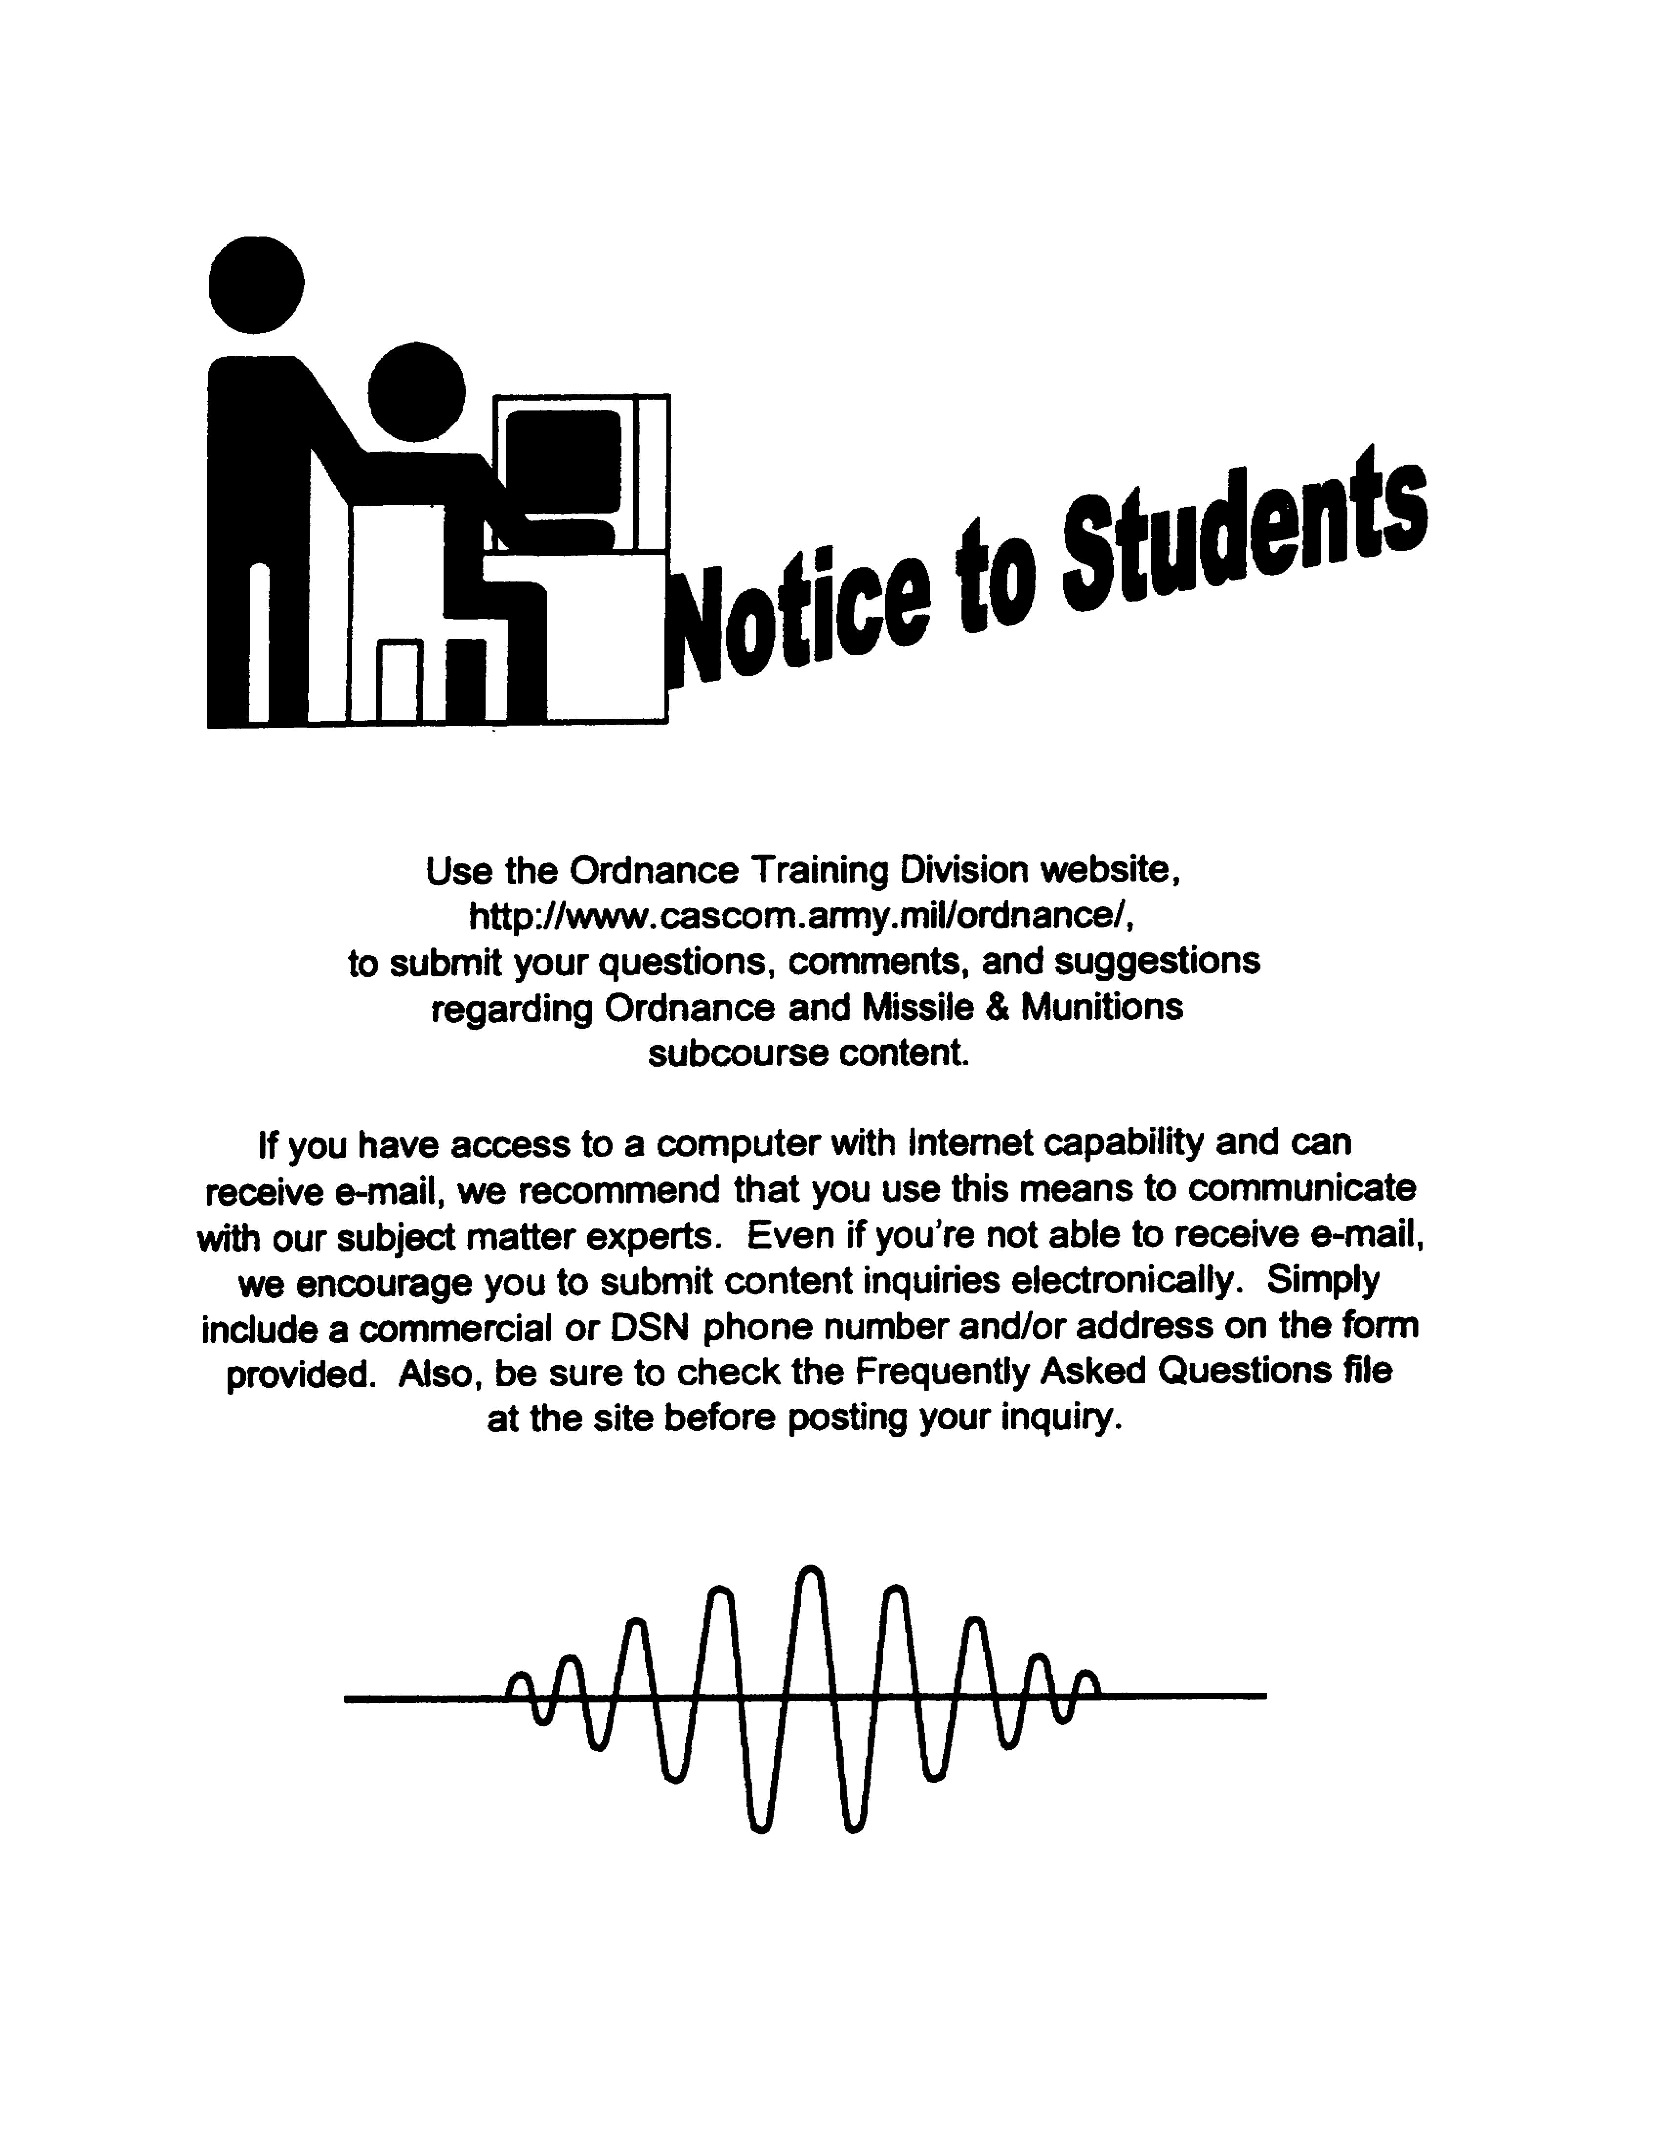

INTRODUCTION TO SIMPLIFIED TEST EQUIPMENT/
INTERNAL COMBUSTION ENGINES (STE/ICE)

SUBCOURSE OD0455

United States Army Combined Arms Support Command
Fort Lee, VA 23801-1809

9 Credit Hours

GENERAL

The purpose of this subcourse is to provide you with a knowledge of the components and component operation of simplified test equipment/internal combustion engines (STE/ICE) and the correct performance of test and fault isolation procedures for gasoline and diesel engines.

The scope of this subcourse broadly covers the STE/ICE. Upon completion of this subcourse, the student should have a basic knowledge of the STE/ICE, components and operation.

Nine credit hours are awarded for successful completion of this subcourse. It consists of two lessons of two tasks each and an examination as follows:

Lesson 1: COMPONENTS AND COMPONENT
OPERATION OF SIMPLIFIED TEST
EQUIPMENT/INTERNAL COMBUSTION
ENGINES (STE/ICE)

TASK 1: Identify the major components of simplified test equipment/internal combustion engines (STE\ICE).

TASK 2: Define component operation of simplified test equipment/internal combustion engines (STE/ICE).

i

INTRODUCTION TO STE/ICE - OD 0455

Lesson 2: CORRECT PERFORMANCE OF TEST AND FAULT
ISOLATION PROCEDURES ON GASOLINE AND
DIESEL ENGINES

TASK 1: Identify the correct procedures for performing test and fault isolation on gasoline engines.

TASK 2: Identify the correct procedures for performing test and fault isolation on diesel engines.

ii

INTRODUCTION TO STE/ICE - OD 0455

TABLE OF CONTENTS

Section Page

TITLE i

TABLE OF CONTENTS iii

Lesson 1: COMPONENTS AND COMPONENT
OPERATION OF SIMPLIFIED
TEST EQUIPMENT/INTERNAL COMBUSTION
ENGINES (STE/ICE) 1

Task 1: Identify the Major Components of
Simplified Test Equipment/
Internal Combustion Engines
(STE/ICE 1

Task 2: Define Component Operation of
Simplified Test Equipment/
Internal Combustion Engines
(STE/ICE) 6

Practical Exercise 1 17

Answers to Practical Exercise 1 21

Lesson 2: CORRECT PERFORMANCE OF TEST AND
FAULT ISOLATION PROCEDURES ON
GASOLINE AND DIESEL ENGINES 22

Task 1: Identify the Correct Procedures
for Performing Test and Fault
Isolation on Gasoline Engines 22

Task 2: Identify the Correct Procedures
for Performing Test and Fault
Isolation on Diesel Engines 37

Practical Exercise 2 56

Answers to Practical Exercise 2 60

iii

INTRODUCTION TO STE/ICE - OD 0455

REFERENCES 61

*** IMPORTANT NOTICE ***

THE PASSING SCORE FOR ALL ACCP MATERIAL IS NOW 70%.

PLEASE DISREGARD ALL REFERENCES TO THE 75% REQUIREMENT.

iv

INTRODUCTION TO STE/ICE - OD 0455

When used in this publication "he," "him," "his," and "men" represent both the masculine and feminine genders, unless otherwise stated.

v

INTRODUCTION TO STE/ICE - OD 0455

STUDENT NOTES

vi

INTRODUCTION TO STE/ICE - OD 0455 LESSON 1/TASK 1

LESSON 1

COMPONENTS AND COMPONENT OPERATION OF SIMPLIFIED
TEST EQUIPMENT/INTERNAL COMBUSTION
ENGINES (STE/ICE)

TASK 1. Identify the major components of
simplified test equipment/internal
combustion engines (STE/ICE).

CONDITIONS

Within a self-study environment and given the subcourse text, without assistance.

STANDARDS

Within two hours

REFERENCES

No supplementary references are needed for this task.

1. Introduction

The engines in military vehicles today are more complex than ever. For maintenance personnel to repair these engines in a safe and timely manner, they need a testing device that will allow them to quickly and accurately troubleshoot the various systems of the engine. That testing device is the simplified test equipment/internal combustion engines (STE/ICE) test set.

The simplified test equipment/internal combustion engines (STE/ICE) test set is a versatile tool. It is used for testing and taking measurements on vehicle engines as well as other electrical and mechanical equipment. The test set is housed in a protective transit case and is easily transported to a test site, complete with all necessary accessories.

1

INTRODUCTION TO STE/ICE - OD 0455 LESSON 1/TASK 1

2. Components

The STE/ICE test set consists of four major components: the vehicle test meter (VTM), transducer kit (TK), cable assemblies and the transit case.

a. Vehicle Test Meter (VTM). The VTM is a computer-controlled vehicle multi-test meter that was designed to be compact and simple to operate and understand. It is used for testing electrical and mechanical components. The readings on the VTM are displayed as either PASS/FAIL or as a digital display (such as pounds per square inch [psi], revolutions per minute [rpm], volts, etc.). The power for the VTM comes from the batteries of the vehicle/equipment being tested or from an alternate power source of 9 to 32 volts direct current (VDC). The VTM interfaces with the vehicle/equipment being tested through transducers from the transducer kit (TK) or through the diagnostic connector assembly (DCA). Figure 1 shows the VTM.

FIGURE 1. VEHICLE TEST METER.
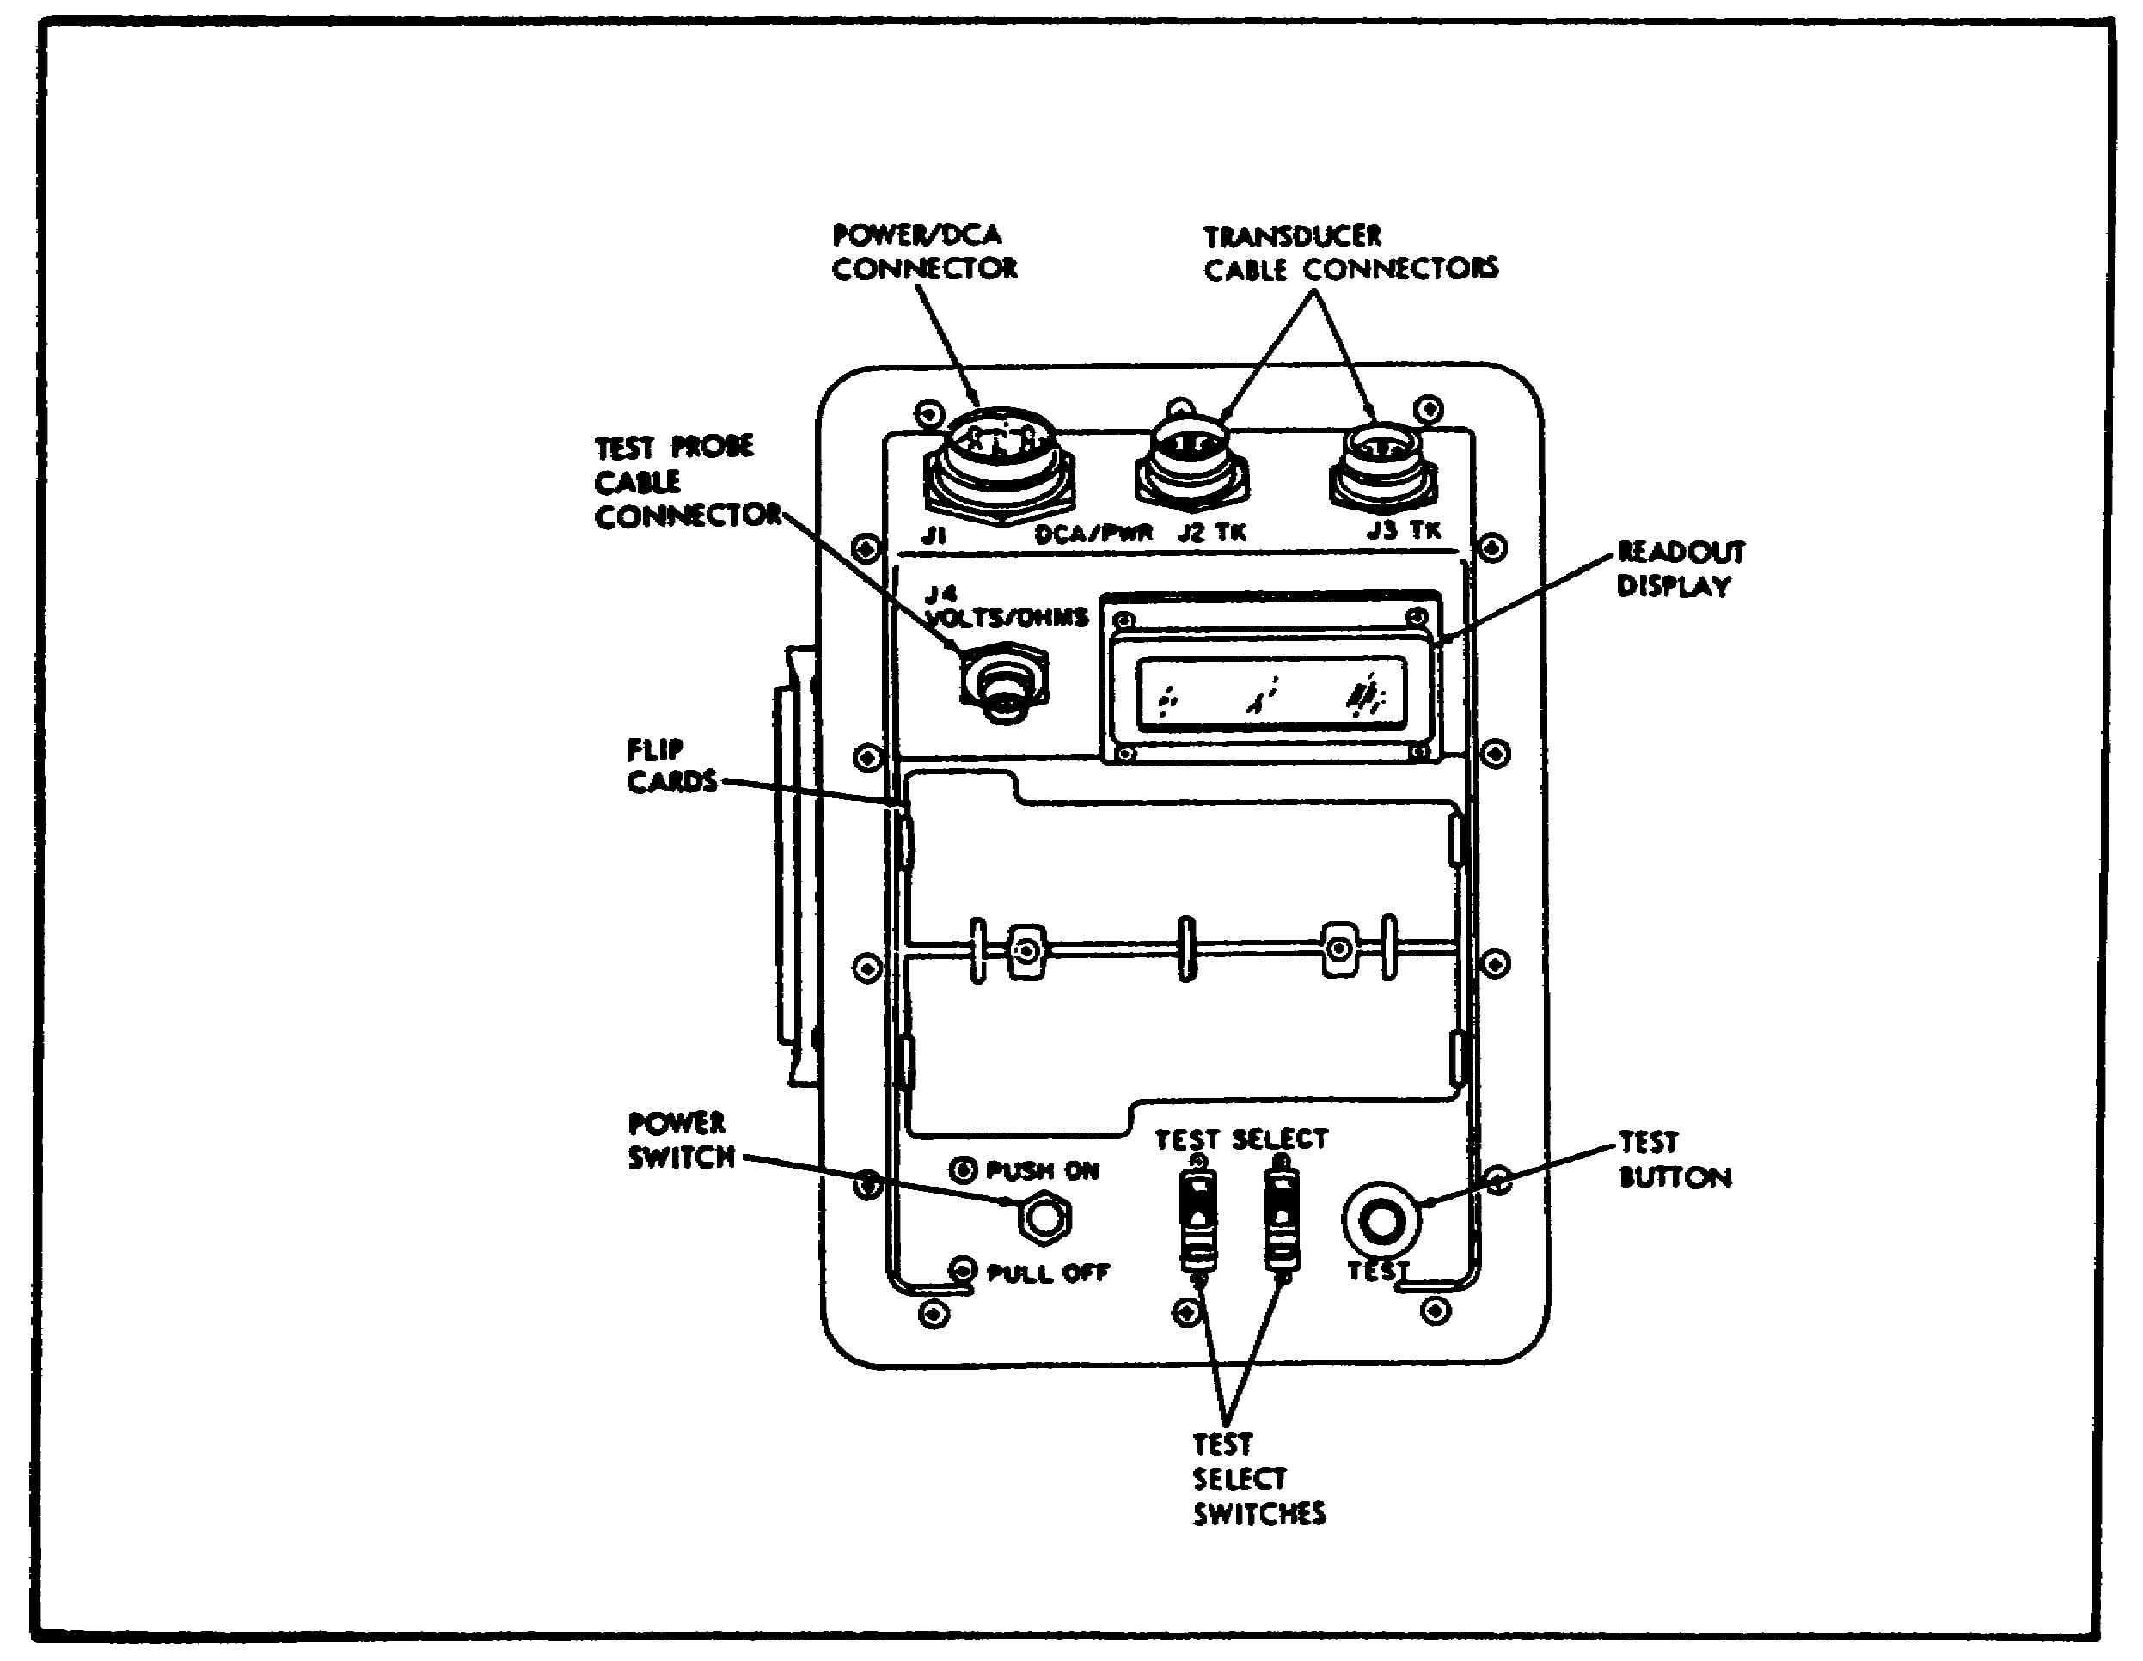

2

INTRODUCTION TO STE/ICE - OD 0455 LESSON 1/TASK 1

b. Transducer Kit (TK). The TK is a collection of transducers and transducer adapters that can be used with vehicles that do not have DCAs or in combination with DCAs. The TK allows the mechanic to attach the VTM to different components on the vehicle or equipment being tested. The transducers and transducer adapters are mounted in a tray that fits inside the transit case. Figure 2 shows the transducer kit and several of the transducers and transducer adapters.

FIGURE 2. TRANSDUCER KIT.
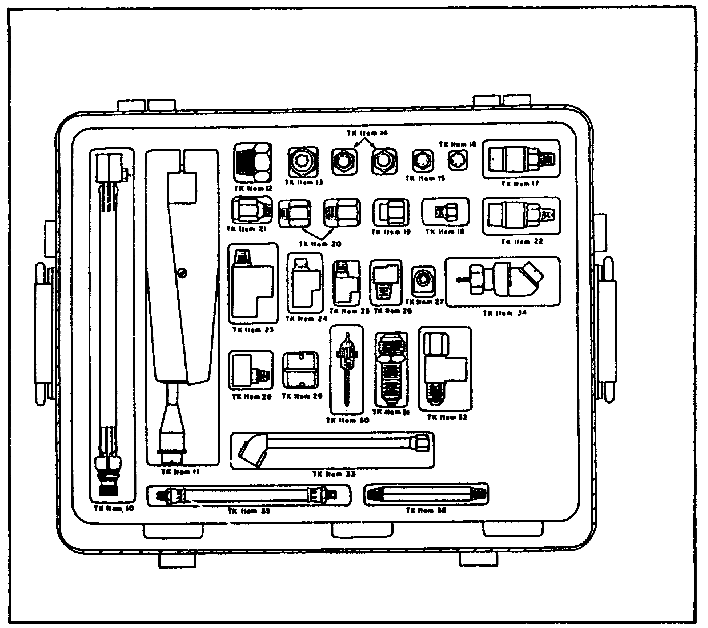

3

INTRODUCTION TO STE/ICE - OD 0455 LESSON 1/TASK 1

c. Cable Assemblies. The cable assemblies are also considered a major component. All the cables in the STE/ICE test set are of the NATO type, so they can be used throughout the NATO forces. The cable assemblies are a quick-release sleeve type and are marked at the connectors for easy identification, installation and removal. These cables are:

(1) W-1. The diagnostic connector assembly (DCA) cable used with the DCA on the vehicle.

(2) W-2. The test probe cable. Used for measuring volts and ohms.

(3) W-3. The ignition adapter cable for spark ignition (SI) engines (TK mode only).

(4) W-4. The transducer cable (TK mode only).

(5) W-5. The power cable (TK mode only.)

Figure 3 shows the cable assemblies with the five types of cables identified.

FIGURE 3. CABLE ASSEMBLIES.
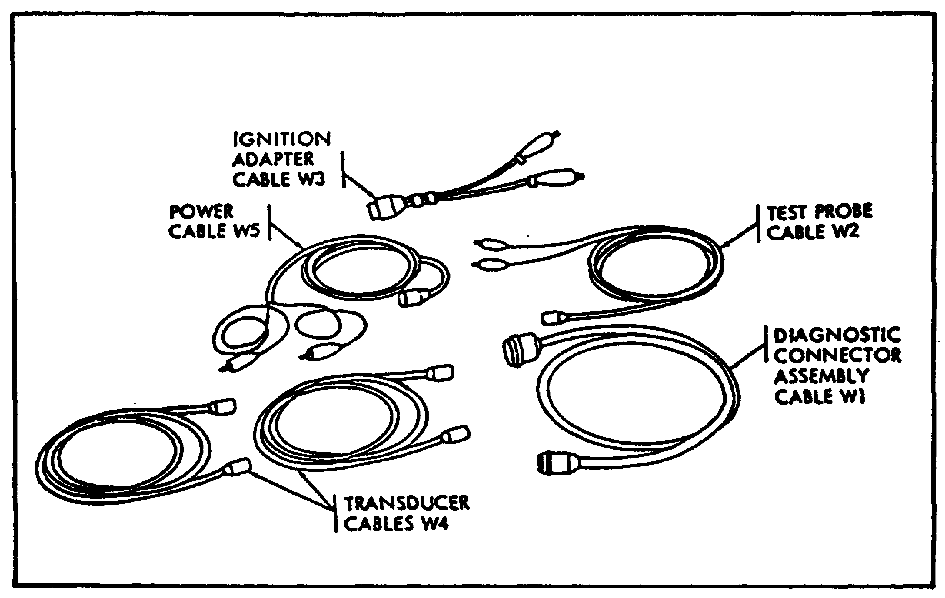

4

INTRODUCTION TO STE/ICE - OD 0455 LESSON 1/TASK 1

d. Transit Case. The transit case is a portable protective case that houses the STE/ICE test set and all necessary accessories. A pressure relief valve, on the front of the case, allows the operator to relieve any pressure that may have built up due to changes in climate during transit. Figure 4 shows the transit case with the pressure relief valve.

FIGURE 4. TRANSIT CASE.
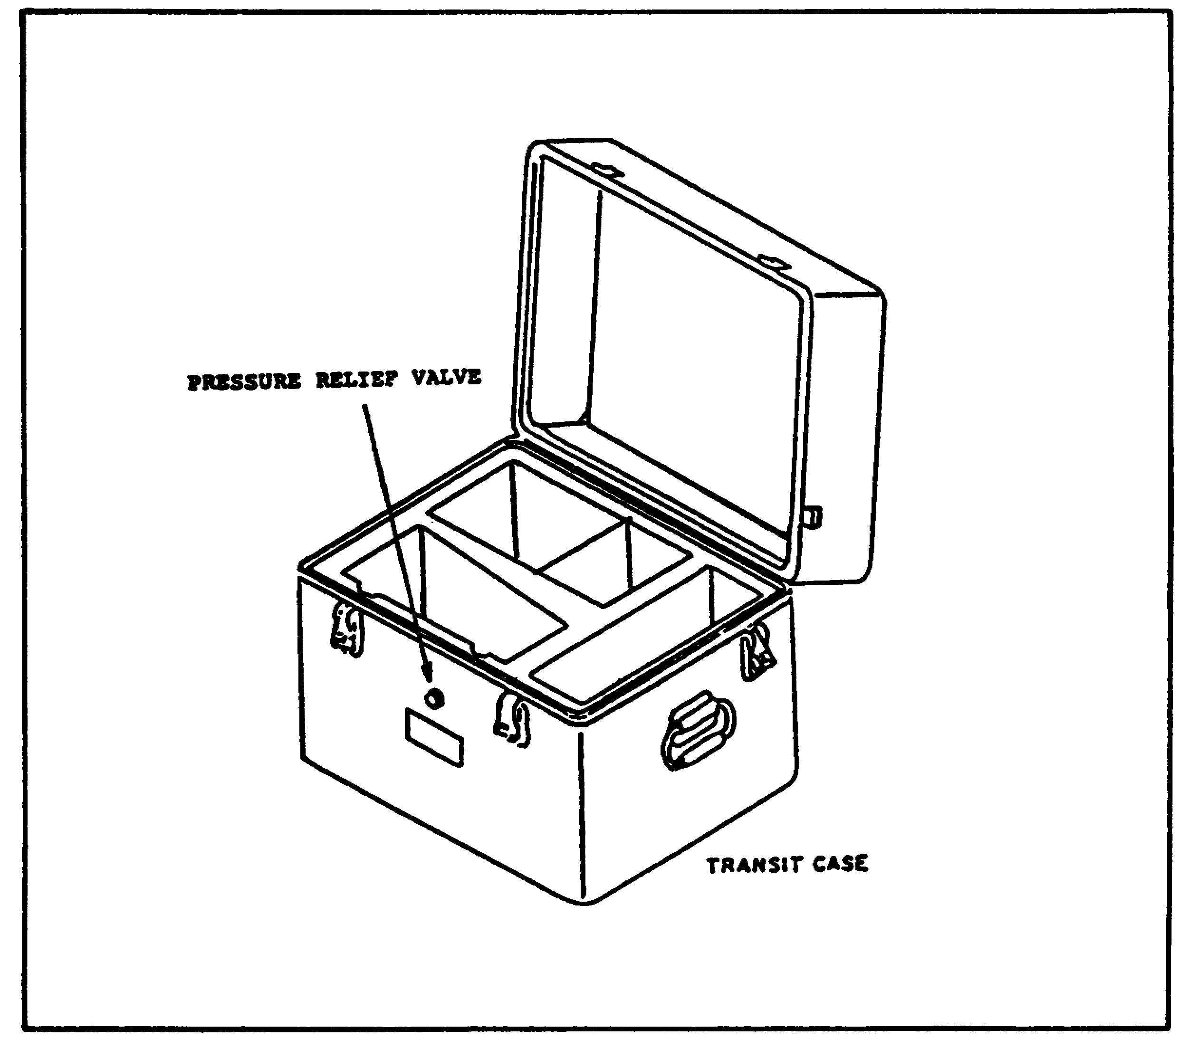

5

INTRODUCTION TO STE/ICE - OD 0455 - LESSON 1/TASK 2

LESSON 1

COMPONENTS AND COMPONENT OPERATION OF SIMPLIFIED
TEST EQUIPMENT/INTERNAL COMBUSTION
ENGINES (STE/ICE)

TASK 2. Define component operation of simplified test equipment/internal combustion engines (STE/ICE).

CONDITIONS

Within a self-study environment and given the subcourse text, without assistance.

STANDARDS

Within two hours

REFERENCES

No supplementary references are needed for this task.

1. Introduction

In the previous task, the four major components of the STE/ICE test set were identified and their functions were discussed.

In this task, the operation of each component and the different operations that each is capable of performing, as well as how they perform these operations, will be discussed.

2. Operation of the Vehicle Test Meter (VTM)

The switches and controls on the VTM (refer to figure 1) will be discussed before going on to its operation.

a. Power Switch. The first switch is the power switch (PUSH ON/PULL OFF). The VTM can operate either from a 9 volt or 32 volt battery system. The power switch controls the direct current (DC) power that the VTM receives. When the switch is

6

INTRODUCTION TO STE/ICE - OD 0455 - LESSON 1/TASK 2

pushed in, the power is ON. To shut OFF the power, the switch is pulled out. A 4 amp circuit breaker causes the switch to pop out if something is wrong. If the power switch pops out, check your hookup carefully and try again before turning the VTM into intermediate direct support (IDS) maintenance.

b. Test Select Switches. TEST SELECT switches select the actual test to be performed. Each switch has ten positions, numbered 0 through 9. The VTM reads the numbers dialed into the TEST SELECT switches only when the TEST button is pressed. Changing the TEST SELECT switch positions has no effect until the TEST button is pressed.

c. Test Button. The test measurement begins when the TEST button is depressed and released. The measured value will be displayed in units normally used for the particular vehicle measurement (listed on the flip cards discussed in paragraph 2e). The TEST button must be pressed and released; depressing and holding the TEST button initiates an offset test.

d. Readout Display. The readout display will show different types of readouts during testing, up to a maximum of 4 characters. The readout can be either alphabetic or numeric. Three types of readouts are displayed by the VTM. The status readout keeps the operator informed as to what is happening, such as power applied, failed test, etc. The numerical readout is the measured value, in units, of the measurement being made. For example, if you are measuring 0-45 volts direct current (VDC), the number 24 on the display indicates 24 volts. The error readout indicates that, for example, the wrong test number was selected, the transducer is not connected, or the VTM is faulty.

e. Flip Cards. The flip cards show the 2 digit test numbers used for selecting the various tests. They also summarize the test and operating instructions contained in TM 9-4910-571-12&P.

f. Power/Diagnostic Connector J1. Connector J1 connects the VTM to either a vehicle diagnostic connector using the DCA cable, or to the vehicle batteries using the power cable. The operating power and signals from the transducers are supplied to the VTM through the DCA cable.

7

INTRODUCTION TO STE/ICE - OD 0455 - LESSON 1/TASK 2

g. Transducer Connectors J2, J3. Connector J2 or J3 connects the VTM to any transducer in the transducer kit. Operating power is supplied to the transducer and signals from the transducers are supplied to the VTM through the cable. Connectors J2 and J3 are identical and can be interchanged with each other or used in combination.

h. Test Probe Connector J4. Connector J4 connects test leads to the VTM when doing manual voltage and resistance tests.

NOTE

In this task, we will cover only the GO chain tests. Refer to TM 9-4910-571-12&P for the procedures to be followed in performing NO-GO chain test.

3. Self-Tests for the Vehicle Test Meter (VTM)

a. Confidence Test. The VTM has two built in self-test features. The first of these is the confidence test. The confidence test provides an overall performance check of the VTM and includes programmed isolation to assist in IDS maintenance. The confidence test should be run immediately after power has been applied to the VTM. To run the confidence test, the following procedures must be observed and/or performed.

First, ensure that the VTM is correctly connected to the vehicle to be tested and that sufficient operating power is available. The display should show .8.8.8.8, then change to four dashes (- - - -). Next, set the TEST SELECT switches to 66 and press and release the TEST button. The display should show 0066. When 0066 appears on the readout display, set the TEST SELECT switches to 99 and again press and release the TEST button. Observe the displayed readout. The display should show 0099 and then go blank. When performing this particular step, you should observe the display and verify that all segments of the display are on. The display should then show .8.8.8.8. If any segments of the display are not working, refer to the TM for the removal and installation of digital display modules. Again, the display should show several other numbers, go blank and then flash the word PASS.

8

INTRODUCTION TO STE/ICE - OD 0455 - LESSON 1/TASK 2

b. Offset Test. The offset test is made before any vehicle measurement is made. The offset test nulls out characteristic differences on the VTM, test leads and transducers. The offset test also zeros the meter. Once the offset test has been performed, the VTM automatically corrects for the offset before displaying measured values. The displayed offset should be checked against the limits printed on the vehicle cards. If the displayed value is outside these limits, either the transducer or test cable is faulty and must be replaced. The offset test is performed by dialing the test number into the TEST SELECT switches and depressing and holding the TEST button down until the VTM displays the prompting message of CAL.

4. Test Numbering System

The STE/ICE has the capability to perform 99 different tests; however, not all of these tests are being used at this time. The test numbers for the STE/ICE are broken down as follows:

TEST TESTS
NUMBERS

10-15 Engine
16-23 Ignition
24-34 Fuel/air system
35-38 Lubrication/cooling system
39-57 Pressure/temperature system
67-88 Starting/charging system
89-99 Electrical

5. Control Functions

In addition to these tests, the STE/ICE also has control functions that change the way a measurement is displayed or run. The vehicle test meter (VTM) displays the current test value and updates this display every 1/2 second. Control tests change the process to allow for more in-depth analysis of engine performance. The STE/ICE is capable of performing five control tests. These control functions and their respective test select numbers are briefly described next.

a. Interleave (01). This causes the display to alternate between the test that was entered and a measurement of engine speed. This control test is useful when a measurement is to be made at a particular engine speed. An ignition adapter cable

9

INTRODUCTION TO STE/ICE - OD 0455 - LESSON 1/TASK 2

or pulse tachometer must be attached if the VTM is not powered through a diagnostic connector assembly.

b. Display Minimum Values of Next Measurement (02).

This causes the VTM to display the lowest value measured during a test. This test is useful when the lowest value of measurement is needed; for example, when looking for the lowest manifold vacuum on a spark ignition engine.

c. Display Maximum Value of Next Measurement (03). This causes the VTM to display the highest value measured during a test. This test is useful when the greatest value of a measurement is needed, as when measuring cylinder pressure.

d. Display Peak-to-Peak Values of Next Measurement (04). This causes the VTM to display the difference between the highest value and the lowest value measured between display changes during a test. The peak-to-peak control function can be used with the dwell measurement to determine dwell difference between the cam lobes.

e. Park Ignition Full Power Simulation (05). This allows the user to simulate full power operation on spark ignition engines while making measurements (for example, maximum fuel flow without maximum engine speed). The spark ignition full power simulation will continue until the vehicle throttle is released.

6. Vehicle Testing

The STE/ICE system was designed as a tool for the mechanic to use in testing both the electrical and mechanical components on vehicles. To troubleshoot a vehicle problem, the mechanic can use the STE/ICE (VTM and transducers), TM 9-4910-571-12&P, and the vehicle test cards (VTC) along with the vehicle's own TMs.

At the beginning of the testing sequence, it is usually necessary for the operator to enter vehicle information into the VTM. The VTC will tell the operator or mechanic what data is required. The reason for entering this vehicle data is that certain tests require vehicle or cylinder information to be done properly. If the vehicle identification is entered, then the number of

10

INTRODUCTION TO STE/ICE - OD 0455 - LESSON 1/TASK 2

cylinders is automatically entered. Now, the two types of vehicle information that may be required will be discussed.

a. Cylinder Entry Test #58. The cylinder entry test number 58 calls for the number of cylinders or the number of cylinder pairs to be entered. The operator can check the VTC or the flip card on the VTM if he doesn't know the number to enter. The VTM's response to test number 58 is to display CYL. This is the signal to dial the number of cylinders into the TEST SELECT switches and press and release the TEST button. The VTM will not try to perform a test, it will simply remember the number of cylinders.

b. Error Messages in Cylinder Entry Test #58. If there was a problem with the number that was entered, one of the following error messages will be displayed: E007, E010, E014, E015. If one of these error messages is displayed while the VTM is connected to DCA ID number 13, testing may be continued. Refer to the appropriate vehicle TM to determine whether you are connected to DCA ID number 13. For all other DCAs, a correct number must be entered. These error messages are:

(1) E007-indicates a conflict between the vehicle identification (VID) dialed in and the number of cylinders dialed in. It may occur in response to either VID entry or number-of-cylinders entry.

(2) E010-indicates that a wrong VID number was dialed into the VTM.

(3) E014-indicates that a wrong number of cylinders was dialed into the VTM.

(4) E015-indicates that the number of cylinders dialed into the VTM in the DCA mode conflicts with the number of cylinders in the vehicle. This error message applies to spark ignition vehicles only.

c. VID Entry Test #60. VID entry test number 60 calls for the VID to be entered. This number is given on the VTCs and also in TM 9-4910-571-12&P. If the vehicle being tested is not listed on the VTC, select a vehicle with the same number of cylinders and power output and use that vehicle's VID number.

11

INTRODUCTION TO STE/ICE - OD 0455 - LESSON 1/TASK 2

The VTM's response to test number 60 is to display UEH. This is the signal for you to dial the VID number into the TEST SELECT switches and press and release the TEST button. The VTM will not perform a test, it just remembers the VID. If there is a problem with the number entered, error messages E007 or E010 will be displayed. These error messages have been described above. If either of these messages is displayed while the VTM is connected to DCA 13, testing may be continued. However, for all other DCAs, a correct VID number must be entered. When the VID is entered, the number of cylinders is automatically entered as well.

d. Data Display Tests. Next, let's cover data display tests number 59 and 61 thru 64. Test number 59 displays the currently stored cylinder information when the TEST button is pressed. Test number 61 displays the currently stored VID number when the TEST button is pressed. Test number 62 displays the currently attached DCA ID number when the TEST button is pressed. Test number 63 displays the ID number of the currently attached transducer on connector J2. Test number 64 displays the ID number of the currently attached transducer on connector J3.

7. Setup and Checkout Procedures for the VTM

Before actually beginning the setup of the VTM, a vehicle pre-inspection must be performed.

a. Pre-inspection Checks. This includes checking the fan belts for proper tension and replacing them if they are cracked and frayed. Next, check the ignition cables to ensure they are securely attached and in good condition. Check the oil level; if it is low, bring the oil up to the proper level. Ensure that the fuel tank has enough fuel for testing. Check and fill the radiator if necessary. Finally, inspect the battery for a cracked case at the terminal posts; replace the battery if it is damaged. Clean off all corrosion and check that the battery connections to ground and to the starter motor are in good condition, securely connected and clean. Check and fill the battery with electrolyte if it is low. After the vehicle pre-inspection has been completed, connect the VTM and power cable to the vehicle to be tested. Remove the VTM and power cable from the transit case and connect the power cable to the VTM

12

INTRODUCTION TO STE/ICE - OD 0455 - LESSON 1/TASK 2

and clip the leads to the batteries (red to positive, black to negative).

b. VTM Power Supply. The VTM normally receives its power from power cable W5 connected to the batteries of the vehicle/equipment under test. If those batteries are dead, the VTM can receive power by connecting power cable W5 to the batteries of another adjacent vehicle/equipment. As a possible third source of power, the VTM can utilize a DCA cable plugged into any vehicle/equipment DCA connector. However, in this mode of power, no revolutions per minute (rpm) measurement can be made on the vehicle/equipment under test.

NOTE

If the VTM case touches certain vehicles while the master switch is OFF and the VTM power is ON, sparking may occur. Some vehicle accessories may turn ON and the VTM power switch may pop to OFF. This can happen on vehicles with the master relay in the negative battery cable. The sparking won't hurt the VTM or the vehicle, but it will interrupt your testing. You can prevent it by setting the VTM down so that only its rubber feet touch the vehicle, or by doing all testing with the master switch ON.

After the VTM has been connected to the vehicle batteries, apply power to the VTM by pushing on the power switch. With the power ON, run the confidence test (see paragraph 3a of this lesson). This assures the operator that the VTM's internal circuitry is working normally and that vehicle testing can begin.

8. Vehicle Diagnostics

This portion of the task deals with troubleshooting flowcharts. Vehicle test procedures are presented in task-oriented, illustrated flowcharts covering the testing of vehicle serviceability (Go Chain) and fault isolation (No-Go Chain). Task branching is controlled by "yes" and "no" decisions. Generally, a "yes" leads to the next task, while a "no" leads to a specific No-Go Chain. The No-Go Chain is a series of symptoms-oriented (no start, no cranking), illustrated flowcharts similar to

13

INTRODUCTION TO STE/ICE - OD 0455 - LESSON 1/TASK 2

those in the Go Chain. The Go and No-Go Chains are separated into three sections as follows: spark ignition transducer kit (TK), compression ignition TK, and compression ignition DCA.

a. A Typical Go Chain Test. The next lesson will use the information presented in this lesson to perform test and fault isolation procedures on gasoline and diesel engines.

FIGURE 5. GO CHAIN FLOWCHART.
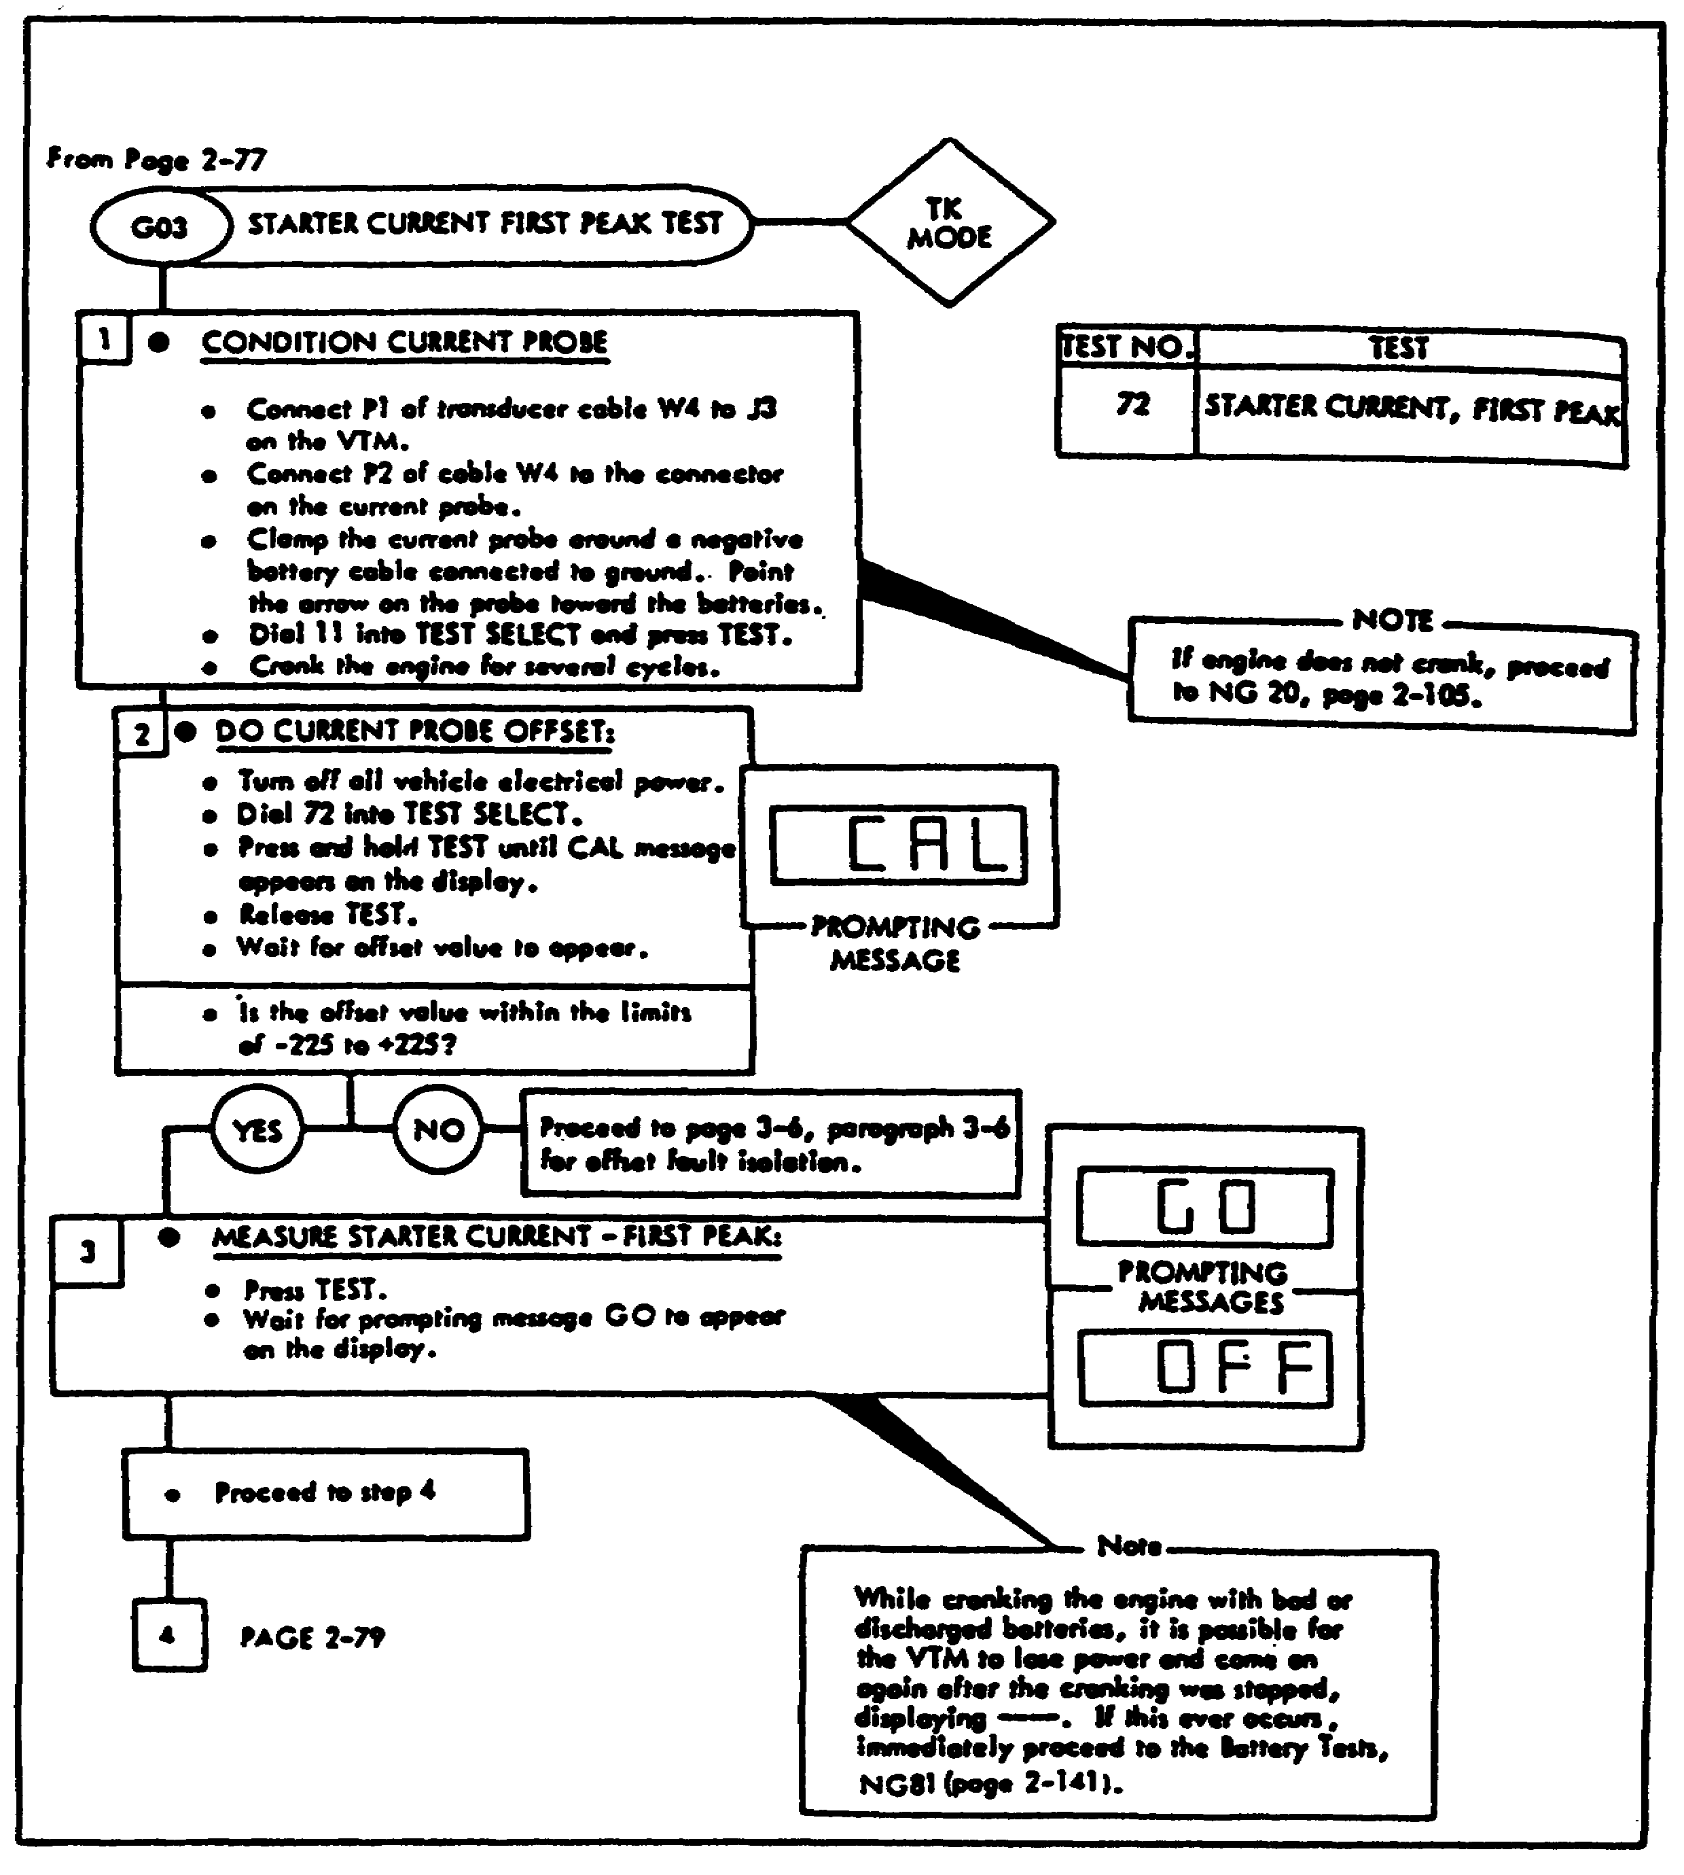

14

INTRODUCTION TO STE/ICE - OD 0455 - LESSON 1/TASK 2

FIGURE 5. GO CHAIN FLOWCHART (cont.).
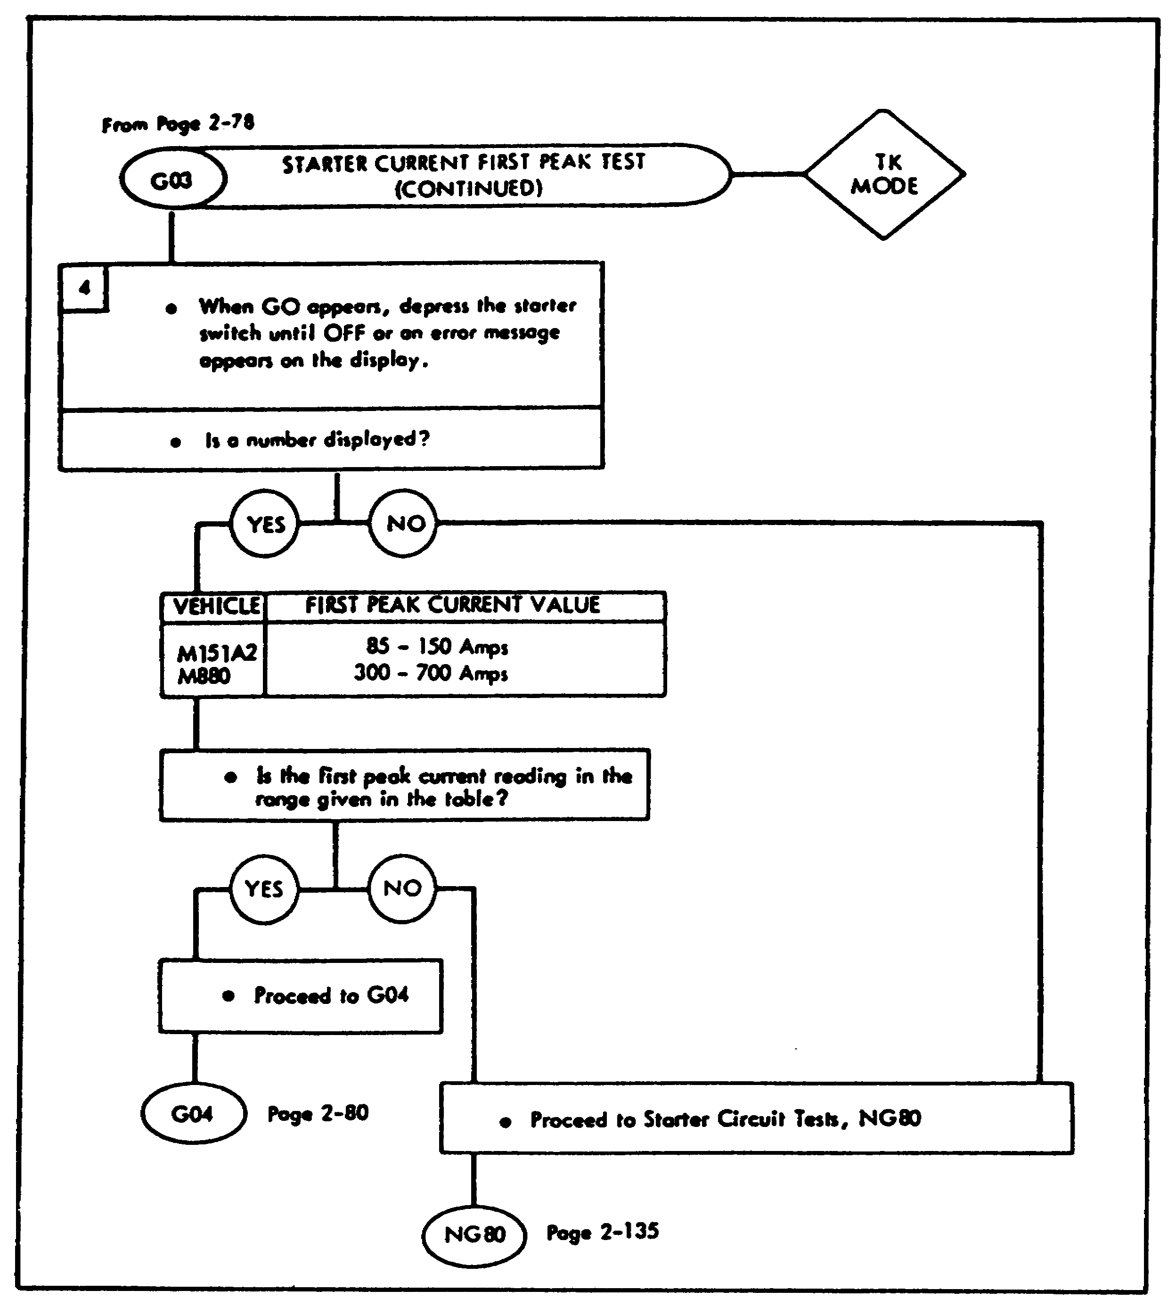

Figure 5, on the previous page and above, is a flowchart for a typical Go Chain test. This flowchart is GO 3, STARTER CURRENT FIRST PEAK TEST. This gives an idea of what the flowcharts look like and how they are used. On the page after the flowchart, the procedures for performing this particular test are covered. Use the flowchart to follow along and gain an idea of how to read the flowchart.

15

INTRODUCTION TO STE/ICE - OD 0455 - LESSON 1/TASK 2

b. Go Chain Steps. A typical Go Chain, GO 3, STARTER CURRENT FIRST PEAK TEST, will now be covered step-by-step. To begin this test, condition the current probe. This is accomplished by connecting P1 of the transducer cable W4 to J3 on the VTM. Connect P2 of cable W4 to the connector on the current probe. Clamp the current probe around the negative battery cable, which is connected to ground. Point the arrow on the probe towards the batteries. Now, dial 11 into the TEST SELECT switches and press and release the TEST button. Crank the engine for several cycles.

Now, perform the current probe offset test. This is done by turning off all vehicle electrical power. Now, dial 72 into the TEST SELECT switches and press and hold the TEST button until the CAL message appears on the display. Release the TEST button and wait for the offset value to appear. If the offset value is not within the limits of -225 to +225, refer to TM 9-4910-571-12&P for the offset fault isolation procedures. If the offset value is within these limits, measure the starter current- first peak. Press the TEST button and wait for the prompting message GO to appear on the display.

NOTE

While cranking the engine with bad or discharged batteries, it is possible for the VTM to lose power and come on again after the cranking has stopped, displaying four dashes (- - - -). If this occurs, immediately proceed to the BATTERY TESTS, No-Go 81 in the TM 9-4910-571-12&P.

When GO appears on the display, depress the starter switch until OFF or an error message appears on the display. If no number is displayed, proceed to the STARTER CIRCUIT TESTS, No-Go 80 in TM 9-4910-571-12&P. If a number is displayed and this number is not within the limits listed in the vehicle TM, then proceed to No-Go 80, STARTER CIRCUIT TESTS in TM 9-4910-571-12&P. If the number is within the limits given in the TM, proceed to GO 4, ENGINE START-LUBRICATION CHECK.

16

INTRODUCTION TO STE/ICE - OD 0455 - LESSON 1/PE 1

PRACTICAL EXERCISE 1

1. Instructions

Read the scenario and respond to the requirements that follow the scenario.

2. Scenario

You are the training NCO for a mechanized infantry company. The company commander has informed you that many of the soldiers in the motor pool section do not fully understand the operation of the STE/ICE test set. Therefore, he has charged you with conducting several training sessions to bring these soldiers up to speed on the STE/ICE. You determine that your first course of action is to prepare a pretest to test the knowledge of these soldiers. Together with the motor pool sergeant, you prepare a pretest consisting of ten questions to be administered to the soldiers in the motor pool section prior to planning the training course. However, before the motor pool sergeant and you could make up an answer sheet for the pretest, he was called to the field to assist in the recovery of a disabled vehicle.

Requirement

Using the knowledge you have gained from this subcourse, devise an answer sheet for the questions listed below.

Item 1

The STE/ICE test set is composed of how many components?

A. 4

B. 3

C. 2

D. 1

17

INTRODUCTION TO STE/ICE - OD 0455 - LESSON 1/PE 1

Item 2

What are three major components of the STE/ICE test set?

A. Malfunction switch, chronometer, and cables

B. Main voltage adapter, electronic clamps, and vehicle test meter (VTM)

C. Vehicle test meter (VTM), cables, and transducer kit (TK)

D. NATO adapter, container and multimeter

Item 3

Which of the following statements concerning the cables of the STE/ICE test set is most correct?

A. All the cables in the STE/ICE test set are of the NATO type

B. There are only two types of cables in the test set

C. The cables in the STE/ICE test set are not the quick-release sleeve type

D. The cables in the STE/ICE test set cannot be used throughout the NATO forces

Item 4

The transducer kit (TK) allows the mechanic to attach the VTM to

A. only the diagnostic connector assembly (DCA).

B. only the vehicle batteries.

C. different components.

D. instrument panel connections.

18

INTRODUCTION TO STE/ICE - OD 0455 - LESSON 1/PE 1

Item 5

The STE/ICE test set has how many built-in self-tests?

A. 6

B. 4

C. 3

D. 2

Item 6

Which of the following statements concerning the offset test is most correct?

A. The offset test can be made at any time during testing

B. The offset test does not zero the meter

C. The offset test nulls out characteristic differences on the VTM, test leads and transducers

D. The VTM will not automatically correct for the offset before displaying measured values

Item 7

Which is the first test number dialed into the TEST SELECT when performing the confidence test?

A. 99

B. 66

C. 59

D. 58

19

INTRODUCTION TO STE/ICE - OD 0455 - LESSON 1/PE 1

Item 8

The VTM requires a power source of how many volts direct current?

A. 120

B. 110

C. 9 to 32

D. 6 to 9

Item 9

When the power has been applied to the VTM, the display should show .8.8.8.8 for about 2 seconds and then change to

A. 0099.

B. 0066.

C. - - - -

D. AL.

Item 10

When performing confidence/ID entry test number 60, what information would be entered into the VTM when UEH appears on the display?

A. The number of cylinders

B. The vehicle identification number

C. Test number 58

D. Test number 01

20

INTRODUCTION TO STE/ICE - OD 0455 - LESSON 1/PE 1

LESSON 1. PRACTICAL EXERCISE - ANSWERS

Requirement

1. A

2. C

3. A

4. C

5. D

6. C

7. B

8. C

9. C

10. B

21

INTRODUCTION TO STE/ICE - OD 0455 - LESSON 2/TASK 1

LESSON 2

CORRECT PERFORMANCE OF TEST AND FAULT ISOLATION
PROCEDURES ON GASOLINE AND DIESEL ENGINES

TASK 1. Identify the correct procedures for performing test and fault isolation on gasoline engines.

CONDITIONS

Within a self-study environment and given the subcourse text, without assistance.

STANDARDS

Within two hours

REFERENCES

No supplementary references are needed for this task, but access to TM 9-4910-571-12&P will be helpful.

1. Introduction

The first lesson of this subcourse covered the components and the operation of the STE/ICE test set. This lesson will cover the performance of test and fault isolation procedures on gasoline and diesel engines.

As was stated in the introduction to lesson 1, today's spark ignition (gasoline) and compression ignition (diesel) engines are extremely complicated; the most modern test equipment available must be used to troubleshoot them. However, if maintenance personnel don't know how to use the test set properly, they will either damage the test set and the vehicle, or get erroneous readings and be unable to properly troubleshoot and repair the vehicle. The purpose of this lesson is to teach the proper use of the test set to troubleshoot both gasoline and diesel engines.

22

INTRODUCTION TO STE/ICE - OD 0455 - LESSON 2/TASK 1

2. STE/ICE Tests

a. Hook-up and Power-up Procedures. To begin; the hook-up of the test set to the vehicle's batteries and the power-up procedures will be discussed.

CAUTION

Do not connect or disconnect the vehicle test meter (VTM) while the engine is running.

CAUTION

Connect P1 of power cable W5 to J1 on the VTM before connecting the clip leads to the battery.

First, ensure that the PULL OFF power switch on the VTM is in the OFF position. Then, connect P1 of power cable W5 to J1 on the VTM; then, connect the red clip lead of W5 to the positive (+) terminal of a 24 volt direct current (VDC) or 12 VDC power source (such as a battery). Clip the black clip lead to the negative (-) terminal of the battery.

NOTE

If the VTM case touches some vehicles while the master switch is OFF and the VTM power is ON, sparking may occur. Some vehicle accessories may turn on and the VTM power switch may pop OFF. This can happen on vehicles with the master relay in the negative battery cable. The sparking won't hurt the VTM or the vehicle, but it will interrupt your testing. You can prevent it by ,setting the VTM down so that only its rubber feet touch the vehicle, or by doing all testing with the master switch ON.

Once the VTM has been properly connected to the vehicle batteries, power-up the VTM. This is accomplished by placing the PUSH ON power switch on the VTM to the ON position. The display on the VTM should show .8.8.8.8 for approximately 2 seconds and then change to - - - -. Does the VTM show the proper indication? If yes, then proceed to the next step and run the confidence test (see page 8, paragraph 3a). If the display on the VTM does not

23

INTRODUCTION TO STE/ICE - OD 0455 - LESSON 2/TASK 1

give the proper indication, refer to the TM 9-4910-571-12 & P. After the VTM has been powered up and you have received the proper indication, run the confidence test. The procedures to follow in running the confidence test were discussed earlier (see page 8, paragraph 3a), and they are outlined in the TM.

Now the procedures for performing the power test for spark ignition engines will be covered. The VTM performs a power test on spark ignition engines by interrupting the firing of four out of every five cylinders with the throttle wide open. This allows each cylinder to receive a full flow of fuel and air, but allows the engine to operate at a point where the developed power balances against the engine friction, pumping losses and accessory loads. The power test will run in this mode for about 40 seconds to stabilize operation and make measurements. The engine will work hard and may even backfire while stabilizing.

b. Vehicle Identification Number. Next, enter the vehicle identification number (VID). First, dial 60 into the TEST SELECT, and press and release the TEST button. Wait for a prompting message of UEH to appear on the display. When UEH appears, dial the vehicle identification number into the TEST SELECT switches and press and release the TEST button. If the VTM display shows the VID then proceed with testing. If it does not display the VID, refer to the TM.

c. Connect Cables. Connect P1 of transducer cable W4 to J2 on the VTM; then, connect P2 of transducer cable W4 to P1 of ignition adapter cable W3. Ensure that the hookup has been performed in accordance with the instructions presented in paragraph 2a on page 23. Be sure that the black clip lead is connected to a good ground. Run the engine at idle and dial 10 into the TEST SELECT switches; then, press the TEST button. If the engine idle is within the specifications outlined in the vehicle TM, proceed to CHECK VTM INTERRUPT CIRCUITRY OPERATION, described in paragraph 2d on page 25.

24

INTRODUCTION TO STE/ICE - OD 0455 - LESSON 2/TASK 1

CAUTION

Operation of the VTM interrupt circuitry is checked before performing any power tests. This prevents possible engine damage.

CAUTION

Do not overspeed the engine during the following test. Interrupt should occur before 3500 rpm.

CAUTION

Do not perform more than 2 power tests in succession.

d. CHECK VTM INTERRUPT CIRCUITRY OPERATION. Dial 05 into the TEST SELECT switches, but DO NOT press the TEST button. Increase the engine speed to slightly above 3500 rpm and hold the speed constant. Now, press and release the TEST button. If the engine does not miss, and the VTM does not display PASS, reduce the rpm to normal idle and check the W3 connections and the ignition adapter, if used; repeat test. If the VTM still fails to display PASS, replace the STE/ICE test set. If the engine misses and the VTM displays PASS, perform the power test.

e. PERFORM POWER TEST. Dial 13 into the TEST SELECT switches and press the TEST button. Wait for the prompting message of SIP to appear. When SIP appears, press down sharply on the accelerator and hold it to the floor until the engine stops. When the engine stops, a number will appear on the VTM. This displayed number is the power test result.

3. Test Operating Procedures, SI Engine

a. POWER TEST (% POWER; TEST 13). Before running a power test, warm up the engine and bring it to idle. Test 13 is dialed into the TEST SELECT switches and the TEST button is pressed and released. The VTM will then display SIP. This is a signal to the operator to press the accelerator to the floor and hold it there. The VTM will monitor engine speed during acceleration and, at approximately 3500 rpm, will begin to interrupt the ignition. The VTM then waits 40 seconds to allow the engine to settle and to allow the carburetor

25

INTRODUCTION TO STE/ICE - OD 0455 - LESSON 2/TASK 1

bowl to empty and fill at least once. During this time, engine speed is monitored by the VTM. If the engine speed falls below 1600 rpm, an LO message is displayed and the test is aborted. At the end of 40 seconds, interrupting is stopped and the engine is allowed to accelerate 600 rpm above the interrupt speed. When this new speed is reached, the VTM kills the ignition entirely and displays the percent of rated power produced by the engine during the test

b. POWER TEST (RPM/SEC)(TEST 12). This test is used only when the vehicle ID is not known. The operating procedure is the same as that described in 3a., above. Two sets of two numbers are displayed. The first is in units of rpm, the second is in units of rpm per second.

(1) To perform this test on the M151A2, remove the plug from the top of the distributor and install the ignition adapter, hand tight, in place of the removed plug. Connect the red clip lead of the ignition adapter cable W3 to the adapter and connect the black clip lead of W3 to a good ground.

(2) To perform this test on the M880, connect the red clip lead of the ignition adapter cable W3 to the electronic control unit/distributor (ECU/DIST) terminal of the ignition coil. Connect the black clip lead of W3 to a good ground.

(3) Once the connections have been made, perform the VTM GENERAL SETUP AND CHECKOUT PROCEDURES, described in lesson 1, task 2, para. 7a on page 12, prior to doing this test.

c. STARTER CURRENT FIRST PEAK TEST. The next Go Chain test is GO 3, STARTER CURRENT FIRST PEAK TEST. The procedures for this test were described in lesson 1, task 2 para. 8b., on page 16; therefore, they will not be repeated here.

d. ENGINE START-LUBRICATION CHECK. Next, the procedures for test GO 4, ENGINE START-LUBRICATION CHECK will be covered.

CAUTION

Check the oil level before starting the engine.

26

INTRODUCTION TO STE/ICE - OD 0455 - LESSON 2/TASK 1

WARNING

Do not remove the radiator cap when the engine is hot. Wait until the engine cools.

To begin this test, check all fluid levels. Check the oil level and add oil if necessary. Remove the radiator cap and check the coolant level; add coolant if necessary. Check the battery electrolyte level and add distilled water if necessary. Next, dial 10 into the TEST SELECT switches and press the TEST button. Try to start the engine. Does the engine crank and start? If the engine does not start, does the engine crank?

If the engine doesn't crank, turn off the ignition switch and proceed to No-Go test 20 NO CRANK-NO START. If the engine cranks but doesn't start, proceed to the test procedures for ENGINE CRANK-NO START, No-Go 10.

If the engine cranks and starts, check the vehicle oil pressure gage for the minimum oil pressure specified in the vehicle TM. Is the oil pressure above the minimum specified in the TM? If the oil pressure is not above the minimum specified in the TM, stop the engine and proceed to the LOW OIL PRESSURE CHECK, No-Go 5. If the oil pressure is above the minimum listed in the TM, does the generator indicator read normally?

If the generator indicator does not read normally, proceed to GO 5, CHARGING CIRCUIT AND BATTERY VOLTAGE tests. If the generator indicator does read normally, check all the other vehicle gages for proper readings.

Do all gages show normal or proper readings? If they do, proceed to GO 5, CHARGING CIRCUIT AND BATTERY VOLTAGE tests. If the gages did not read normally, did the gage stay at zero or immediately go to full scale when the engine was started? If the gages did not stay at zero or immediately go to full scale, refer to the vehicle TM to locate and correct the problem.

NOTE

After completing repairs, rerun the Go Chain tests to verify that the problem has been corrected and that no other

27

INTRODUCTION TO STE/ICE - OD 0455 - LESSON 2/TASK 1

problems exist. If the gages stay at zero, or immediately go to full scale, proceed to No-Go 31 (GAGE TEST) to troubleshoot the gages.

e. The CHARGING CIRCUIT AND BATTERY VOLTAGE TEST. To begin, the engine rpm must be set by adjusting the engine speed to a fast idle and turning the vehicle headlights and accessories ON, to load the charging system. Next, measure the battery voltage by dialing 67 into the TEST SELECT switches and pressing and releasing the TEST button. Watch the display and verify that the battery voltage is within the limits specified in the vehicle TM. If the battery voltage is not within the limits, or if it is low, refer to the TM for the procedures to follow in continuing to troubleshoot this problem. If the voltage is within the limits, and the generator indicator or gage does not read normally, refer to the vehicle TM to troubleshoot the generator indicator or wiring.

If the generator gage reads normally, turn off the lights and accessories and proceed to G06, ENGINE WARMUP/COOLANT CHECK/OIL PRESSURE TEST. The procedures for performing this test are in TM 9-4910-571-12 & P.

f. No-Go 20, NO CRANK-NO START. To begin this test, try to crank and depress the starter switch. Listen to the starter motor. Does the starter motor sound like it is running overspeed? If the starter motor does not sound like it is running overspeed, or if the sound is a buzz, hum, click, etc., or there is no sound, proceed to STARTER CIRCUIT TESTS No-Go 80 in TM 9-4910-571-12&P. If the starter motor sounds like it is running overspeed, check the teeth on the flywheel. Refer to the vehicle TM and remove the starter motor. Check for missing and/or damaged teeth on the flywheel. Are all the teeth on the flywheel good? If they are not, notify intermediate direct support (IDS) maintenance. If the teeth are good, refer to the vehicle TM to replace the starter motor or starter solenoid. After completing repairs, rerun the Go Chain tests to verify that the problem has been solved and that no other problems exist.

g. No-Go 31, GAGE TEST. Start by checking the gage needle. Turn the ignition switch from ON to OFF and tap on the gage lightly to verify that the gage needle rests all the way to the left with the

28

INTRODUCTION TO STE/ICE - OD 0455 - LESSON 2/TASK 1

power off. Does the gage read all the way to the left? If it does not, refer to the vehicle TM to replace the gage and check the wiring to the gage and sending unit.

After completing the repair, rerun the Go Chain tests to verify that the problem is fixed and that no other problems exist. If the gage does read all the way to the left, install the test probe cable by connecting P1 of the test probe cable W2 to J4 on the VTM and short the red and black clip leads together. Do the test probes offset? Dial 89 into the TEST SELECT switches and press and hold the TEST button until the CAL message appears on the display. Release the TEST button and wait for the offset value to appear on the display.

Is the offset value within the limits of -6.8 to +6.8? If the offset value is not within these limits, then the STE/ICE test set is bad and needs to be replaced. If the offset value is within these limits, isolate the fault to the sending unit or the gage. Remove the connector from the sending unit on the vehicle and connect the red clip lead of W2 to the center conductor of the connector that was removed from the sending unit. Connect the black clip lead to a good ground and press the TEST button while turning the vehicle ignition switch to ON. Does the VTM indicate the battery voltage? If the VTM does indicate the battery voltage, refer to the vehicle TM to replace the sending unit. If the VTM does not indicate the battery voltage, refer to the vehicle TM to check and isolate the fault to the wiring harness and gage. Remember to rerun the Go Chain tests to verify that the problem is fixed and that no other problems exist.

h. No-Go 80, STARTER CIRCUIT TESTS.

NOTE

While cranking the engine with bad or discharged batteries, it is possible for the VTM to lose power and come on again after the cranking has stopped, displaying - - - -. If this occurs, clean the battery posts and clamps and try again. If the VTM still loses power,

29

INTRODUCTION TO STE/ICE - OD 0455 - LESSON 2/TASK 1

connect the VTM power cable to good batteries in another vehicle and perform the following tests, using the test probe cable W2.

(1) Current Probe Offset. Turn off all vehicle electrical power and dial 74 into the TEST SELECT switches. Press and hold the TEST button until the CAL message appears on the display, then release the TEST button. Wait for the offset value to appear on the display. If the offset value is not within the limits of -225 to +225, refer to TM 9-4910-571-12&P for the fault isolation procedures.

NOTE

Be sure the ignition adapter cable W3 is connected as shown in test G02, HOOK UP OF W3 CABLE, page 2-77 of TM 9-4910-571-12&P. During this test, the VTM disables the ignition to keep the engine from starting.

(2) Starter Circuit Resistance. Next, check the starter circuit resistance by pressing the TEST button. When GO appears on the VTM display, attempt to crank the engine. Stop cranking the engine when the VTM displays OFF, or an error message. If a number is displayed (between 8 and 350 milliohms), this number is the starter circuit resistance. If the resistance is within the range specified in the vehicle TM, then the problem is due either to weak batteries or a tight engine. Proceed to the BATTERY RESISTANCE test, No-Go 81. If a number is not displayed, refer to TM 9-4910-571-12&P.

(3) Starter Current. Now, check the starter current. This is done by dialing 90 into the TEST SELECT switches and pressing the TEST button. Crank the engine and check to see whether the starter current is above 50 amps. If the starter current is above 50 amps, and error message E013 is displayed, refer to the TM 9-4910-571-12&P for the procedures to follow. Install the test probe cable by connecting P1 of test probe cable W2 to J4 on the VTM and shorting the red and black clip leads together.

30

INTRODUCTION TO STE/ICE - OD 0455 - LESSON 2/TASK 1

(4) Test Probe Cable Offset. Now, perform the test probe cable offset. First, dial 89 into the TEST SELECT switches, and press and hold the TEST button until the CAL message appears on the display. If the offset value is not within the limits -6.8 to +6.8, then the STE/ICE test set is bad and needs to be replaced. If the offset value is within these limits, check the starter voltage.

(5) Starter Voltage. Begin by connecting the black clip lead to the negative battery terminal, and the red clip lead to the positive terminal, on the starter motor. Press the TEST button and crank the engine while observing the display. If the starter voltage is above 17 volts for a 24 volt system, or 8.5 volts for a 12 volt system, check the starter for a negative voltage drop.

(6) Starter Negative Voltage Drop. First, move the red clip lead to the ground terminal of the starter motor. Dial 89 into the TEST SELECT switches and press the TEST button. Crank the engine and observe the displayed voltage. If the displayed voltage is not 0.5 volts or less, proceed to the BATTERY COMPARTMENT NEGATIVE SIDE VOLTAGE CHECKS, No-Go 121. If the displayed voltage is 0.5 volts or less, refer to the vehicle TM to replace the starter motor. If the starter voltage is not above 17 volts for a 24 volt system, or 8.5 volts for a 12 volt system, check the starter solenoid voltage.

(7) Starter Solenoid Voltage. Move the red clip lead to the positive terminal on the starter solenoid or foot switch. Dial 89 into the TEST SELECT switches and press the TEST button. Crank the engine and observe the displayed voltage. If the starter solenoid voltage is above 18 volts for an M151A2, or 9 volts for an M880, and the starter circuit resistance was high, proceed to the BATTERY COMPARTMENT-POSITIVE SIDE VOLTAGE DROP CHECKS NO-Go 120. If a GO message was displayed while checking the starter circuit resistance test, check the switches, connections and wiring to the solenoid or foot switch. If these are all OK, replace the solenoid or foot switch. If the displayed voltage is not 18 volts for an M151A2, or 9 volts for an M880, check the battery voltage while cranking.

(8) Battery Voltage. Dial 67 into the TEST SELECT switches and press the TEST button. Crank the engine and observe the displayed voltage. If

31

INTRODUCTION TO STE/ICE - OD 0455 - LESSON 2/TASK 1

the voltage was above 9.5 volts for an M880, or above 19 volts for an M151A2, proceed to the BATTERY TEST, No-Go 81. If the correct voltages were indicated, check the switches, wiring and connections to the starter solenoid or foot switch and repair as necessary. Refer to TM 9-4910-571-12&P, page 2-199 for the procedures for performing No-Go 81, BATTERY TESTS.

i. No-Go 120, BATTERY COMPARTMENT-POSITIVE SIDE VOLTAGE DROP CHECKS.

NOTE

Refer to the vehicle TM for voltage drops in the battery compartment. Check the voltage drop across the solenoid, and all cables/connections in the positive side of the starter circuit. Use the procedures outlined in the subparagraphs that follow for each voltage drop check.

(1) Test Probe Cable Offset. Short the clip leads of cable W2 together. Dial 89 into the TEST SELECT switches and press and hold the TEST button until the CAL message appears on the display. Release the TEST button and wait for the offset value to appear on the display. Is the offset value within the limits of -6.8 to +6.8? If the offset value is not within these limits, then the STE/ICE test set is bad and needs to be replaced. If the offset value is within these limits, measure the voltage drop.

Connect the clip leads of W2 across the part to be measured. Press the TEST button and depress the starter switch. Compare the voltage drop appearing on the readout display with the specification given in the vehicle TM.

NOTE

If voltage drops are not available, the drop across a connection should be less than 0.1 volt, and the drop across a cable should be less than 0.2 volt.

(2) Remedying Defects. Refer to the vehicle TM to repair or replace the defective part. Remember to rerun the Go Chain test to verify that the problem is fixed and that no other problems exist.

32

INTRODUCTION TO STE/ICE - OD 0455 - LESSON 2/TASK 1

j. No-Go 121, BATTERY COMPARTMENT-NEGATIVE SIDE VOLTAGE DROP CHECKS. The procedure here is identical to the procedures for performing No-Go 120, BATTERY COMPARTMENT-POSITIVE SIDE VOLTAGE DROP CHECKS, described in para. (i)(1) in lesson 2 task 1, on the previous page.

k. No-Go 60, CHARGING CIRCUIT TEST.

WARNING

Turn the vehicle engine off!

To begin this test procedure, install the current probe. This is done by clamping the current probe around the output wire from the alternator, or, in generator-equipped vehicles, the output wire from the regulator. Point the arrow on the probe away from the alternator/regulator and do the current probe offset test.

(1) Current Probe Offset Test. Begin by turning off all vehicle electrical power and dial 90 into the TEST SELECT switches. Press and hold the TEST button until the CAL message appears on the display. Release the TEST button and wait for the offset value to appear on the display. If the offset value is not between -225 to +225, refer to the TM for offset fault isolation procedures. If the offset value is within the limits, check the charging system output current.

(2) Charging System Output Current. This is accomplished by starting the vehicle engine and turning on the vehicle's lights. Set the engine speed to fast idle and press the TEST button. Compare the number on the display with the output current specification listed in the vehicle/equipment TM.

If the current is below the limits specified, then the output current is greater than that specified in the vehicle TM. Use the current probe to locate the accessory or wire drawing excessive current.

If the current is going into the batteries, check the electrolyte level and specific gravity and refer to the vehicle TM to make necessary repairs.

If the output current is below the limit specified, shut off the engine and headlights, and check the drive belts. Refer to the vehicle TM for the

33

INTRODUCTION TO STE/ICE - OD 0455 - LESSON 2/TASK 1

procedures for checking the alternator/generator drive belts for proper tension.

If the drive belts are not OK, refer to the vehicle TM for the procedures for adjusting or replacing the drive belts.

If the drive belts are OK, and the voltage regulator is not built into the alternator/generator, and the vehicle has a 100-amp generator, refer to the vehicle TM for further tests.

If the vehicle does not have a 100 amp generator, leave the current probe connected to the VTM and proceed to INSTALL CURRENT PROBE-DO THE OFFSET; the OFFSET test was described in paragraph 3 (b), in lesson 1, task 2, on page 9; this step will be covered in para. k (4), below.

If the voltage regulator is built into the alternator/generator, refer to the vehicle TM and observe the WARNING and CAUTION notes below.

WARNING

Disconnect battery ground cable to prevent a short.

CAUTION

The alternator is close to the exhaust manifold. Do not allow the cables or probe to contact hot metal. They may melt.

(3) Install Test Probe Cable. This is done by removing the access cover to expose the output terminal on the alternator/generator. Connect P1 of the test probe cable W2 to J4 on the VTM; short the red and black clip leads together.

(4) Perform the Test Probe Cable Offset. This is done by reconnecting the battery ground and dialing 89 into the TEST SELECT switches. Press and hold the TEST button until the CAL message appears on the display. Release the TEST button and wait for the offset value to appear on the display.

24

INTRODUCTION TO STE/ICE - OD 0455 - LESSON 2/TASK 1

If the offset value is not between -6.8 to +6.8, then the STE/ICE is bad and needs to be replaced.

If the offset value is between these limits, check the charging system output voltage. First, connect the red lead to the output terminal of the alternator/generator. (The output terminal is the stud with the largest wire connected to it). Next, connect the black clip lead to ground and start the vehicle engine. Turn on the vehicle lights and accessories and set the engine speed to fast idle.

Press the TEST button and compare the reading against the VTM display with the output voltage specifications in the vehicle TM. If the output voltage is within the limits specified, then refer to the vehicle TM to repair bad connections or broken cables in the charging system output and ground circuits.

Rerun the Go Chain tests, after completing repairs, to verify that the problem is solved and that no other problems exist.

If the output voltage is not within the limits specified, check the ignition sense output. Refer to the vehicle test cards (VTC) to disconnect the voltage sensing wire from the alternator/generator. Connect the black clip lead to ground and connect the red clip lead to the ignition side of the sensing wire. Turn the ignition switch on and check the reading on the display to see if it is near battery voltage.

If the reading on the display is near battery voltage, refer to the vehicle TM to replace the alternator/generator.

If the reading is not near battery voltage, stop the engine and turn off the headlights and all the accessories. Disconnect the battery ground and reinstall the access cover on the alternator. Reconnect the battery ground and refer to the vehicle TM to repair bad connections or broken wires from the ignition switch to the alternator/generator.

Now, install the current probe and perform the OFFSET test. With the ignition switch off, install the current probe around the field wire on the alternator/generator. Turn off all vehicle electrical power and dial 90 into the TEST SELECT

35

INTRODUCTION TO STE/ICE - OD 0455 - LESSON 2/TASK 1

until the CAL message appears on the display. Release the TEST button and wait for the offset value to appear on the display.

If the offset value is not between -225 to +225, then refer to the vehicle TM fault isolation procedures.

If the offset value is within the specified limits, check the field current. Begin by starting the vehicle engine and setting the engine speed to fast idle. Turn the headlights on and press the TEST button. If the number displayed is a negative number, remove the probe and reposition it in accordance with the procedures presented earlier (page 33, para. k.), in this task. Re-install the probe with the arrow pointing the other way and repeat the previous step. Compare the number on the VTM display with the field current specifications listed in the vehicle TM.

NOTE

The current probe must be at least 10 inches from the alternator/generator.

If the value displayed is greater than the limits specified, then refer to the vehicle TM to replace the alternator/generator. If the value displayed is not greater than the limits specified, turn off the headlights and shut off the vehicle engine. Refer to the vehicle TM for the troubleshooting procedures for the alternator/generator field circuit, field cables and regulator.

36

INTRODUCTION TO STE/ICE - OD 0455 - LESSON 2/TASK 2

LESSON 2

CORRECT PERFORMANCE OF TEST AND
FAULT ISOLATION PROCEDURES ON
GASOLINE AND DIESEL ENGINES

TASK 2. Identify the correct procedures for performing test and fault isolation on diesel engines.

CONDITIONS

Within a self-study environment and given the subcourse text, without assistance.

STANDARDS

Within two hours

REFERENCES

No supplementary references are needed for this task.

1. Introduction

In the first task of this lesson, performing test and fault isolation procedures for gasoline or spark ignition engines was covered. Now, the same procedures for diesel or compression ignition engines will be discussed.

Many of the vehicles in the Army's inventory have diesel engines, so it is important that maintenance personnel have a thorough understanding of the procedures for using the STE/ICE test set. To prevent serious injury to personnel, all warnings listed for compression ignition engines in TM 9-4910-571-12&P and the vehicle TM must be observed.

2. Installation of the Pulse Tachometer

The pulse tachometer is a component in the STE/ICE test set transducer kit (TK) that is used to sense the engine speed only on compression ignition or diesel engines.

37

INTRODUCTION TO STE/ICE - OD 0455 - LESSON 2/TASK 2

WARNING

To prevent damage to equipment or injury to personnel, turn engine off before installing pusle tachometer.

CAUTION

Clean all mounting surfaces before installing pulse tachometer to prevent the entry of foreign substances that may damage the engine or transducer.

a. Vehicles with a Tachometer. On vehicle/equipment with a tachometer on the instrument panel, it may be possible to disconnect the drive cable from the back of the tachometer and connect the STE/ICE pulse tachometer to it using adapter TK item 31. If erratic readings occur or if no measurement is detected, the drive cable may be faulty. Connect the pulse tachometer directly to the engine or to the right angle drive on the engine. Locate the test point on the vehicle/equipment for pulse tachometer installation by using the vehicle TM.

To use the pulse tachometer on vehicles equipped with a tachometer, refer to the vehicle TM for the procedures for disconnecting the tachometer cable from the engine. Install the pulse tachometer in place of the removed tachometer cable. Connect P1 of the transducer cable W4 to J2 on the vehicle test meter (VTM) and connect P2 of the transducer cable to the connector on the pulse tachometer.

CAUTION

Be sure cable W4 is clear of belts and fan blades.

b. No-Go 20, NO CRANK-NO START. Set the vehicle controls to crank the engine and depress the starter switch; listen to the starter motor to see if it sounds as if it is running overspeed. If the starter motor does not sound like it is running overspeed or if the sound is a buzz, hum, click, etc., or if there is no sound at all, proceed to STARTER CIRCUIT TESTS, No-Go 80 (paragraph 2e, page 41).

38

INTRODUCTION TO STE/ICE - OD 0455 - LESSON 2/TASK 2

If the starter motor sounds like it is running overspeed, check the teeth on the flywheel. Refer to the vehicle TM for the procedures for removing the starter motor and check for missing and/or damaged teeth on the flywheel. If they are good, refer to the vehicle TM to replace the starter solenoid or starter motor. Rerun the Go Chain tests to verify that the problem has been solved and that no other problems exist. If the teeth on the flywheel are missing and/or damaged, notify intermediate direct support (IDS) maintenance.

c. No-Go 30, ENGINE CRANK-NO START. To begin, shut off the fuel and dial 10 into the TEST SELECT switches; then press the TEST button. Crank the engine and watch the readout display. Compare the result with the minimum cranking speed as listed in the vehicle TM. If the cranking speed is not OK, proceed to the STARTER CIRCUIT TESTS, No-Go 80 (paragraph 2e, page 41).

If the cranking speed is OK, check the fuel supply by verifying that there is fuel in the tank.

If the fuel filters have been changed or if the fuel tank has been run dry, refer to the vehicle TM to bleed air out of the fuel system as necessary. Drain any water from the primary fuel filter and continue to drain until fuel appears. Check for kinked, flattened or broken fuel lines from the tank to the filters and engine. If the vehicle is equipped with a quick-disconnect fitting, check for blockages at the quick-disconnect. Check the fuel shut off solenoid and circuitry and the emergency fuel shut off.

Turn on the Fuel and Accessory switch and dial 24 into the TEST SELECT switches and press the TEST button. Crank the engine and watch the readout display. Compare the number on the display with the fuel pressure specification in the vehicle TM.

If the fuel pressure is above the limits specified, refer to the vehicle TM for the proper operation of the fuel shut off device. Check for a restricted air intake. If the engine still does not start and the weather is cold, refer to the vehicle TM to check the cold start devices.

If the vehicle still will not start, notify IDS maintenance. When the vehicle is returned, be sure

39

INTRODUCTION TO STE/ICE - OD 0455 - LESSON 2/TASK 2

to verify that the problem is solved and that no other problems exist. Repeat the Go-chain test.

CAUTION

Before opening the fuel line, make sure that the area around the fuel line is clean.

WARNING

On the LVTP-7, the LVTP-7A, some M113'S and any other vehicle that has the master switch in the negative battery cable, sparking may occur if the vehicle test meter (VTM) case touches the vehicle while the vehicle master switch is off and the simplified test equipment/internal combustion engine (STE/ICE) power is on. This sparking, in the presence of fuel and/or vapors that result from disconnecting fuel lines, presents a potential hazard to personnel. You can prevent this hazard by setting the VTM down so that only the rubber bumpers touch the vehicle or by doing all testing with the vehicle master switch on.

Install the pressure transducer (red stripe) in the inlet side of the primary fuel filter. Connect P1 of the transducer cable W4 to J2 on the VTM and connect P2 of the transducer cable to the connector on the transducer.

Dial 45 into the TEST SELECT switches and press and hold the TEST button until the CAL message appears on the display. Release the TEST button and wait for the offset value to appear on the display.

If the offset value is not within the limits of -4 to +4, refer to chapter 3, section 2 of TM 9-4910-571-12&P for the offset fault isolation procedures.

If the offset value is within these limits, measure the fuel pressure during the cranking. This is done by turning on the fuel and accessory switch and pressing the TEST button. Crank the engine and watch the VTM display. If the reading is greater than 2 inches of mercury and you are in freezing temperatures, refer to the vehicle TM for the procedures to be followed. If the reading is not

40

INTRODUCTION TO STE/ICE - OD 0455 - LESSON 2/TASK 2

greater than 2 inches of mercury, replace the fuel lines and repeat the test step for checking the fuel pressure during cranking.

If the pressure is still low, then the fuel pump is defective. If you are authorized to replace it then do so; if not, notify IDS maintenance.

d. GAGE TEST, No-Go 31. If the vehicle is an LVTP-7A1, refer to the vehicle TM to troubleshoot the gage and sensor and to repair as necessary.

If the vehicle is not an LVTP-7A1, install the test probe cable by connecting Pl of the test probe cable W2 to J4 on the VTM. Short the red and black clip leads together. Dial 89 into the TEST SELECT switches and press and hold the TEST button until the CAL message appears on the display. Release the TEST button and wait for the offset value to be displayed.

If the offset value is not between -6.8 to +6.8, then the STE/ICE is bad and needs to be replaced.

If the offset value is within these limits, isolate the fault to the sending unit or gage. Remove the wire from the temperature sending unit on the vehicle and connect the red clip lead to the Wire removed from the sending unit. Connect the black clip lead to ground and turn the vehicle accessory switch ON.

If the VTM indicates battery voltage, refer to the vehicle TM to check and isolate the fault to the wiring harness or gage.

After making any repairs, remember to rerun the Go Chain Tests to verify that the problem is solved and that no other problems exist.

e. No-Go 80, STARTER CIRCUIT TESTS. While cranking the engine with bad or discharged batteries, it is possible for the VTM to lose power and come-on again after the cranking has stopped, displaying four dashes (- - - -). If this occurs, clean the battery posts and clamps and try again. If the VTM still loses power, connect the VTM power cable to good batteries in another vehicle and perform the following tests using the test probe cable.

41

INTRODUCTION TO STE/ICE - OD 0455 - LESSON 2/TASK 2

(1) Starter Circuit Resistance. Dial 74 into the TEST SELECT switches and press the TEST button. Shut off the fuel so that the vehicle cannot start. When GO appears on the display, crank the engine. Stop cranking when the VTM displays OFF or an error message.

If the display does not show a number, is the word GO still displayed? If the word GO is still not displayed, proceed to the step on checking the starter current as discussed in paragraph 2c(2), below. If the word GO is still displayed, repeat the above procedure. If the word GO is still displayed after cranking, then the starter is not being energized and you should check the starter voltage.

If a number is displayed, compare this number to the test limits listed in the vehicle TM. If the starter circuit resistance is not within the limits listed in the vehicle TM, is the resistance high?

If the resistance is not high, then it is low and you should look for a short in the starter circuit.

If no short is found, then replace the starter motor. Refer to the vehicle TM for the proper procedures to be used.

If the starter circuit resistance is high, check the starter voltage. If the starter circuit resistance is within the limits specified in the vehicle TM, the problem is either due to weak batteries or a tight engine; perform BATTERY TESTS, No-Go 81 (para. 2f, page 44).

(2) Starter Current. Dial 71 into the TEST SELECT switches and press the TEST button. Crank the engine with the fuel shut off. If the starter current is not above 100 amps, proceed to No-Go 81, BATTERY TESTS (para. 2f, page 44).

If the starter current is above 100 amps and error message E013 was displayed when checking the starter circuit resistance, this indicates a short circuit, frozen starter or tight engine. Check the wiring to the starter for short circuits and repair as necessary.

42

INTRODUCTION TO STE/ICE - OD 0455 - LESSON 2/TASK 2

(3) Starter Voltage Check. Dial 68 into the TEST SELECT switches and press the TEST button. Crank the engine and observe the displayed voltage. If the starter voltage is not 17 volts, then check the starter solenoid voltage as discussed in paragraph 2e(4), below.

If the starter voltage is above 17 volts, check the starter negative cable drop. Dial 69 into the TEST SELECT switches and press the TEST button. Crank the engine and observe the displayed voltage.

If the cable drop is not less than the limit on the vehicle test cards (VTC), inspect and clean all ground cables from the starter, engine and batteries and check for integrity; repair as necessary.

If the cable drop is less than the limit on the VTC, refer to the vehicle TM to replace the starter motor.

(4) Starter Solenoid Voltage Check. Dial 70 into the TEST SELECT switches and press the TEST button. Crank the engine and observe the displayed voltage. If the starter solenoid voltage is not above 18 volts, check the battery voltage cranking.

If the starter solenoid voltage is above volts and the starter circuit resistance was high, check the positive battery cables and connections to the starter solenoid and repair the cables are connections as necessary. If the cable and the connections are OK, replace the starter solenoid.

If a GO message occurred during the starter circuit resistance test, check the switches and wiring to the solenoid. If the switches and wiring are all OK, replace the starter/solenoid.

(5) Battery Voltage Check. Dial 67 into the TEST SELECT switches and press the TEST button. Crank the engine and observe the displayed voltage. If the battery voltage was not above 19 volts while cranking, perform BATTERY TESTS, No-GO 81 (para. 2f, page 44).

If the battery voltage was above 19 volts, check the switches and wiring to the starter solenoid and repair as necessary.

43

INTRODUCTION TO STE/ICE - OD 0455 - LESSON 2/TASK 2

Remember, after completing any repair, rerun the Go Chain Tests to verify that the problem has been corrected and that no other problems exist.

f. BATTERY TESTS, No-Go 81. Each battery is best tested individually. During this test the fuel supply must be shut off, to keep the engine from starting.

(1) Install Test Probe Cable and Perform the Offset Test. Connect the test probe cable W2 to J4 on the VTM. Short the red and black clip leads together.

Dial 89 into the TEST SELECT switches and press and hold the TEST button until the CAL message appears on the display. Release the TEST button and wait for the offset value to appear on the display.

If the offset value is not between -6.8 to +6.8, then the STE/ICE is bad and needs to be replaced.

If the offset value is within these limits, connect the red clip lead to the negative post of the battery being tested and connect the black clip lead to the negative post of the battery being tested. Now condition the current probe, and do the offset test. When conditioning the current probe, essentially what is being done is that you are telling the VTM the highest current that it will encounter during this particular test. The current probe is always conditioned prior to performing the offset test.

Clamp the current probe around the battery cable that connects the series pair of batteries containing the battery being tested. Point the arrow on the probe toward the negative post and attempt to crank the engine for several cycles.

Turn off all electrical power and dial 90 into the TEST SELECT switches and press and hold the TEST button until the CAL message appears on the display. Release the TEST button and wait for the offset value to appear.

If the offset value is not between -225 to +225, refer to chapter 3, section 2 of TM 9-4910-571-12&P for the offset fault isolation procedures.

(a) If the offset value is within limits, measure the battery resistance change. Dial 79

44

INTRODUCTION TO STE/ICE - OD 0455 - LESSON 2/TASK 2

into the TEST SELECT switches and press the TEST button. If the word GO does not appear and an error message is displayed, refer to chapter 2, section 1 of TM 9-4910-571-12&P for a definition of the error messages. Correct as necessary and repeat the test.

(b) If the word GO does appear, depress the starter switch until the word OFF appears on the display and wait for the display to change. If a number is not displayed and the word GO is still displayed, there is a bad connection in the starter circuit. Check the cables and connections to the starter and retest.

(c) If the display still shows the word GO, then you may have a very poor battery in the batteries being tested. Test the other battery in the pair.

(d) If the display shows .9.9.9.9, there may be a bad connection on the battery being tested. Clean and tighten the connection and retest. If the display shows E013, four dashes (- - - -), or .9.9.9.9 after the battery has been charged, replace the battery.

(e) If a number is displayed, compare this reading to the resistance change listed in the vehicle TM. If the battery resistance change is not less than the limit listed in the vehicle TM, then check the battery. Check the battery electrolyte level and clean the battery terminals. Refer to the vehicle TM to check the specific gravity of the battery. Change the battery, if necessary, and repeat the test.

NOTE

If the battery fails in freezing weather, crank the engine for 5 seconds and retest. This will warm the battery slightly.

If the battery has been charged and the battery resistance change is greater than the limit, replace the battery.

(f) If the battery resistance change is less than the limit, measure the battery resistance. Dial 77 into the TEST SELECT switches and press the TEST button. If GO appears on the display, depress the starter switch until OFF appears on the display.

45

INTRODUCTION TO STE/ICE - OD 0455 - LESSON 2/TASK 2

(g) If an error message appears on the display, refer to chapter 2, section 1 of TM 9-4910-571-12&P for a description of the error message. Correct as necessary and repeat the test.

(h) If the battery resistance is less than the limit specified in the vehicle TM, the battery is OK. If the vehicle has more than one battery, perform the test on the next battery.

(i) If the battery resistance is not less than the limit, check the battery electrolyte level and clean the battery terminals. After making any repairs, rerun the Go Chain tests to verify that the problem is fixed and that no other problems exist.

g. CHARGING CIRCUIT AND BATTERY VOLTAGE TEST, Go 5. First, set the engine speed by turning on the vehicle headlights and accessories and adjusting the engine speed to fast idle. Next, measure the battery voltage by dialing 67 into the TEST SELECT switches and press the TEST button.

Watch the display and verify that the voltage is between 26.5 to 29.5 volts direct current (VDC). If the battery voltage is within these limits and the generator indicator or gage gives a normal reading, turn off the headlights and accessories, stop the engine and refer to Appendix F of TM 9-4910-571-12&P TM for the procedures to be followed while performing GO 6, ENGINE WARMUP/COOLANT CHECK//OIL PRESSURE TEST.

If the battery voltage is within the limits specified, but the generator indicator or gage does not give a normal reading, refer to the vehicle TM to replace the generator indicator.

Remember, anytime you complete a repair during this section, be sure to rerun the Go Chain tests to verify that the problem is solved and that no other problems exist.

If the battery voltage is not within the limits specified, and the battery voltage is not low, refer to the vehicle TM to adjust or replace the regulator. If the regulator is built into the alternator, replace the entire unit.

46

INTRODUCTION TO STE/ICE - OD 0155 - LESSON 2/TASK 2

If the battery voltage is low, allow the vehicle to run for 5 minutes and watch the display. If the battery voltage is not within the specified limits, turn off the headlights, accessories and the vehicle engine. Refer to para. 2h on page 47 for the procedures to follow in performing the CHARGING CIRCUIT TEST, No-Go 50.

If the battery voltage is within the limits specified, and the generator indicator or gage does not read normally, refer to the vehicle TM for the procedures for troubleshooting the generator indicator and wiring. If the generator indicator or gage gives a normal reading, then turn off the headlights and accessories. Stop the vehicle engine and proceed to the next test.

h. CHARGING CIRCUIT TESTS, No-Go 50.

WARNING

Turn vehicle engine off.

NOTE

For the 650 amp generator, refer to the vehicle TM.

(1) Vehicles with Oil or Fuel Pressure Switches in the Charging Circuit. Begin by installing the current probe around the positive battery cable and pointing the arrow on the probe towards the battery. Now, perform the current probe offset test.

Turn off all vehicle electrical power and dial 90 into the TEST SELECT switches. Press and hold the TEST button until the CAL message appears on the display. Release the TEST button and wait for the offset value to appear on the display.

If the offset value is not between -225 to +225, then refer to chapter 3, section 2 of TM 9-4910-12&P for the offset fault isolation procedures.

If the offset value is within these limits, check the charging system's maximum output current. Dial 03 into the TEST SELECT switches and press the TEST button.

47

INTRODUCTION TO STE/ICE - OD 0455 - LESSON 2/TASK 2

Dial 90 into the TEST SELECT switches and press the TEST button. Start the vehicle engine and turn on the lights and accessories. Set the engine speed to a fast idle and compare the number on the display with the output current listed in the vehicle TM.

If the output current is greater than the output current listed in the vehicle TM, then use the current probe to locate the accessory or wire drawing excessive current.

If the current is going into the batteries, check the electrolyte level and specific gravity. Refer to the vehicle TM to make the necessary repairs.

If the output current is lower than the output current listed in the vehicle TM, shut the engine and vehicle accessories off. If the engine has drive belts, refer to the vehicle TM to check the alternator/generator drive belts for proper tension. If the belts are not OK, refer to the vehicle TM to adjust or repair the belts.

If the engine does not have alternator/generator belts or if the belts are OK, does the vehicle have an oil or fuel pressure switch in the charging circuit? If so, check the operation of the switch and repair if necessary.

Remember to rerun the Go Chain tests to verify that the problem has been solved and that no other problems exist.

If the vehicle is not equipped with an oil or fuel pressure switch in the charging circuit, the test probe cable must be installed to do more testing.

WARNING

Disconnect the battery ground cable before proceeding to prevent arcing with the alternator/generator access removed.

(2) Vehicles without Oil or Fuel Pressure Switches in the Charging Circuit.

NOTE

The following hookup and test may not be possible on all vehicles. If the charging system output voltage is not

48

INTRODUCTION TO STE/ICE - OD 0455 - LESSON 2/TASK 2

accessible at either the regulator or generator/alternator, check the charging system cables for loose or corroded connections, then proceed to check the field current.

To install the test probe cable, remove the access cover to expose the output terminal on the alternator/generator. Connect P1 of the test probe cable W2 to J4 on the VTM. Short the red and black clip leads together.

Dial 89 into the TEST SELECT switches and press and hold the TEST button until the CAL message appears on the display. Release the TEST button and wait for the' offset value to appear on the display.

If the offset value is not between -6.8 to +6.8, then the STE/ICE test set is bad and needs to be replaced.

If the offset value is within these limits, connect the red clip lead to the output terminal of the alternator/generator and connect the black clip lead to ground. Reconnect the battery ground cable and start the vehicle engine.

Turn on the vehicle lights and accessories and set the engine speed to a fast idle.

If the output voltage is between 26.5 and 29.5 volts, refer to the vehicle TM for the procedures used to repair bad connections or broken cables in the charging system output and ground circuits. After completing the repair, rerun the Go Chain test to verify that the problem was solved and that no other problems exist.

If the output voltage is not within these limits, stop the engine and turn off the lights and accessories.

If the voltage regulator is not built into the alternator/generator, check the ignition voltage sense output. Refer to the vehicle TM to disconnect the ignition voltage sensing wire from the alternator/generator. Connect the black clip lead to ground and connect the red clip lead to the switch side of the sensing wire. Turn the accessory switch on.

49

INTRODUCTION TO STE/ICE - OD 0455 - LESSON 2/TASK 2

If the reading on the display is near the battery voltage, refer to the vehicle TM to replace the alternator/generator.

If the reading is not near the battery voltage, refer to the vehicle TM to repair a bad connection or broken wire from the accessory switch to the alternator/generator. Next, check the field current. This is done by installing the current probe around wire No. 1 of the generator-to-regulator cable. Point the arrow on the current probe toward the alternator/generator. Dial 90 into the TEST SELECT switches and press and hold the TEST button until the CAL message appears on the display. Release the TEST button and start the vehicle engine. Set the engine speed to fast idle and turn on the lights and accessories. Press the TEST button and compare the number on the VTM with the values listed in the vehicle TM.

NOTE

On systems with separate rectifiers, the current probe may be placed around wire No. 1 on either the generator-to-rectifier cable or the rectifier-to-regulator cable.

Shut off the vehicle engine.

If the field current is not lower than the field current specification listed in the vehicle TM, replace the alternator/generator using the vehicle TM.

If the field current is low, refer to the vehicle TM to check the continuity of the cables from the regulator to the alternator/generator using the STE/ICE test set. If the cables are OK, refer to Appendix F of TM 9-4910-571 12&P to further check the charging system with the STE/ICE.

Rerun the Go chain tests after completing repairs to verify that the problem was fixed and that no other problems exist.

i. GOVERNOR CHECK/POWER TEST, No-Go 7.

50

INTRODUCTION TO STE/ICE - OD 0155 - LESSON 2/TASK 2

NOTE

The vehicle identification number of test GO 1 must be entered prior to the power test. This will prevent an error message (E004) and subsequent unsuccessful completion of the power test. If you do not have a vehicle ID number but the number of cylinders was entered in GO 1, use test 12, for the power test instead of 13. When using test 12, the first number to appear on the display is the signal to release the accelerator.

CAUTION

Governor operation must be checked before performing the power test to avoid possible engine damage.

Check the governor operation by watching the VTM display and gradually increasing the engine speed to the maximum governor speed indicated in the vehicle TM. Then, depress the accelerator to the full throttle position. If the revolutions per minute (rpm) does not stay within the limits in the vehicle TM, and if the engine rpm is greater than the upper limit, notify IDS maintenance.

If the engine rpm is not greater than the upper limit, but is below the lower limit; proceed to GOVERNOR/POWER TEST FAULT ISOLATION, No-Go 90 (paragraph 21, page 53). If the engine rpm stays within the limits listed in the vehicle TM, perform the power test.

CAUTION

Do not perform the power test if the engine temperature is above the normal operating temperature. However, the engine should be at operating temperature before performing the power test.

With the engine running and at normal operating temperature, dial 13 into the TEST SELECT switches and press the TEST button. Wait for a prompting message of CIP to appear.

When CIP appears, press down on the accelerator and hold it to the floor until the VTM displays OFF.

51

INTRODUCTION TO STE/ICE - OD 0455 - LESSON 2/TASK 2

When OFF appears, release the accelerator; a number representing the percentage of power will appear on the \'TM. Compare this number to that noted in the vehicle TM.

If the power is above the minimum test limit noted in the vehicle TM, proceed to the IDLE SPEED CHECK, GO 7 (paragraph 2j, below).

If the power is not above the minimum test limit and the vehicle does not have a fuel/water separator, perform the GOVERNOR/POWER TEST FAULT ISOLATION, No-Go 90 (paragraph 21, page 53).

If the vehicle does have a fuel/water separator, refer to the vehicle TM to service-the fuel/water separator and repeat the power test.

If the power test still fails, proceed to GOVERNOR/POWER TEST FAULT ISOLATION, No-Go 90 (paragraph 21, page 53).

j. IDLE SPEED CHECK, GO 7. Dial 10 into the TEST SELECT switches and press the TEST button. Refer to the vehicle TM to adjust the engine idle to the rpms shown in the vehicle TM. Watch the VTM display for about 10 seconds to verify that the idle speed remains within tolerance.

If the idle speed does not remain in tolerance, notify IDS maintenance.

If the idle speed remains in tolerance, proceed to the COMPRESSION UNBALANCE TEST, GO 8.

k. COMPRESSION UNBALANCE TEST, GO 8.

CAUTION

Do not perform more than 2 compression unbalance tests in a row or the vehicle batteries may be discharged.

CAUTION

The engine must be at normal operating temperature before performing the compression unbalance test.

52

INTRODUCTION TO STE/ICE - OD 0155 - LESSON 2/TASK 2

NOTE

If testing an M60 vehicle, use the manual fuel shut-off.

Dial 14 into the TEST SELECT switches and press the TEST button. Wait for a prompting message of GO to appear. When GO appears, crank the engine.

Just after starting to crank, the VTM display should change to four dashes (- - - -), indicating that the VTM is accepting data. Stop cranking the engine when the VTM displays OFF or E013 and wait for a number to be displayed.

If the VTM does not display a number but displays GO, repeat the test.

If the VTM displays FAIL, rerun the compression unbalance test. If the FAIL message still appears, notify IDS maintenance.

If the VTM displays E013, this indicates either discharged batteries, low cranking speed, or that the operator stopped cranking during the test. Check and repeat the test.

If the VTM displays a number, compare the number to the test limits listed in the vehicle TM.

If the results are outside the test limits, rerun the test. If the compression unbalance is still out of limits, notify IDS maintenance.

If the compression unbalance is within the test limits, this ends all the GO tests.

l. GOVERNOR/POWER TEST FAULT ISOLATION, No-Go 90. If the vehicle has failed the power test, start with the REMOVE THE AIR CLEANER-REPEAT THE POWER TEST step. If the vehicle has failed the governor check, start with the RUN COMPRESSION UNBALANCE TEST step (para. k, page 52).

CAUTION

Check that the air inlet is clear of tools, debris, dirt and dust before performing the following test.

53

INTRODUCTION TO STE/ICE - OD 0455 - LESSON 2/TASK 2

First, remove the air cleaner and repeat the power test. Remove the air cleaner from the air intake housing. Repeat the power test (para. 6, page 51.)

If the engine passes the power test with the air cleaner out, install a new air filter.

If the engine does not pass the power test with the air cleaner out, reinstall the air cleaner and perform the compression unbalance test (para. 2k, page 52).

If the compression unbalance is within the limits, install the transducer. Install the pressure transducer (blue stripe) in the outlet side of the secondary fuel filter. If the vehicle is an M123AlC, an M520, or an M809, use the pressure transducer with the red stripe instead of the blue striped one.

If the vehicle is an M520 GOER, check the fuel pressure gage on the fuel filter for normal reading at high idle. If the fuel pressure gage reading is normal, notify IDS maintenance.- If the gage reads low, remove it and proceed with installing the transducer to check the pressure with the STE/ICE. Connect P1 of the transducer cable W4 to J2 on the VTM. Connect P2 of the transducer cable to the connector on the transducer.

WARNING

On the LVTP-7, the LVTP-7A1, some M113'S and any other vehicle that has the master switch in the negative battery cable, sparking may occur if the VTM case touches the vehicle while the vehicle master switch is off and the STE/ICE power is on. This sparking in the presence of fuel and/or vapors that result from disconnecting fuel lines presents a potential hazard to personnel. You can prevent this hazard by setting the VTM down so that only the rubber bumpers touch the vehicle or by doing all testing with the vehicle master switch on.

Dial 50 (use 49 for the red stripe transducer) into the TEST SELECT switches. Press and hold the TEST button until the CAL message appears on the

54

INTRODUCTION TO STE/ICE - OD 0455 - LESSON 2/TASK 2

display. Release the TEST button and wait for the offset value to appear on the display.

If the offset value is not between -150 to +150 for the blue stripe transducer, or -4 to +4 for the red stripe transducer, refer to chapter 3, section 2 of TM 9-4910-571-12&P for the offset fault isolation procedures.

If the offset value is within the limits, proceed to measure the fuel pressure at high idle. Press the TEST button, start the engine, and watch the display. Accelerate the engine and hold at high idle.

Compare the number on the display with the fuel pressure specification listed in the vehicle TM. Is the fuel pressure above the limit?

NOTE

If the limit is negative, the test result is above the limit when it is closer to zero than the limit.

If the fuel pressure is above the limit, check the air intake system.

If the fuel pressure is not above the limit, check for crimped or broken lines. Replace the fuel filters if necessary and check the vehicle throttle linkage for full travel and proper adjustment. Make repairs as necessary.

If the reading is still low, notify IDS maintenance.

Next, check the air intake system. If the vehicle is one of the following types, M123AIC, M520, M60, M48, M35A2, M44A2, M809, LVTP-7, refer to the vehicle TM to check the air intake system and repair, if necessary.

If the air intake system is okay, notify IDS maintenance. Inspect the blower air inlet on the following vehicles: M107, M109, M110, M113, M551, M561, M578. If the blower air inlet is not clogged, notify IDS maintenance.

If the blower air inlet is clogged, refer to the vehicle TM to inspect the air intake housing and blower inlet screen and clean if necessary. If the screen and inlet are clean, notify IDS maintenance.

55

INTRODUCTION TO STE/ICE - OD 0455 - LESSON 2/PE 2

PRACTICAL EXERCISE 2

1. Instructions

Read the scenario and respond to the requirements that follow the scenario.

2. Scenario

It has been several weeks since you sat down with the motor pool sergeant to construct the pretest. Since then, you have administered the pretest to the soldiers in the motor pool and held the first class. Based on the results of the test and the questions asked during the class, the motor pool sergeant and you both agree that the area where the soldiers are the weakest is the performance of test and fault isolation procedures for spark ignition (gasoline) and compression ignition (diesel) engines.

The motor pool sergeant suggests that you take the manuals home over the weekend to study. You have studied the manuals and have developed what you think are some pretty good test items. Monday morning, you return the manuals to the motor pool and ask the motor pool sergeant to review your test items and to give you his opinion of them. That afternoon the motor pool sergeant stops by your office to discuss your test items. He says they are very good and asks if you could supply an answer sheet so they can be used in the class.

Requirement

Develop an answer sheet for the test items listed below. The information you need is contained in this subcourse.

56

INTRODUCTION TO STE/ICE - OD 0455 - LESSON 2/PE 2

Item 1

When the vehicle test meter (VTM) of the test set has been correctly hooked up and the PUSH ON power switch is in the ON position, the display of the VTM should show .8.8.8.8 for approximately 2 seconds and then change to

A. 0099.

B. GO.

C. 0066.

D. _ _ _ _.

Item 2

Before performing any vehicle test, the operator must perform a confidence test on the VTM. What is the number code for the confidence test that the operator should dial into the TEST SELECT switches on the VTM?

A. 66

B. 60

C. 58

D. 14

Item 3

When performing the STARTER CURRENT FIRST PEAK TEST, dial 72 into the TEST SELECT switches and press and hold the TEST button until what appears on the display?

A. PASS

B. FAIL

C. CAL

D. GO

57

INTRODUCTION TO STE/ICE - OD 0455 - LESSON 2/PE 2

Item 4

When performing the STARTER CURRENT FIRST PEAK TEST, what are the offset limits?

A. +50 to +235

B. -245 to +75

C. -225 to +225

D. -250 to +250

Item 5

When starting the engine and checking the oil pressure, the engine's rpm is increased to a fast idle. If the display does not show the engine rpm and the cable connections are OK, what fault isolation test would you use?

A. No-Go 90, GOVERNOR/POWER FAULT ISOLATION TEST

B. No-Go 70, ENGINE CRANK-NO SPEED INDICATION

C. No-Go 31, GAGE TEST

D. No-Go 05, LOW OIL PRESSURE CHECK

Item 6

While performing the CHARGING CIRCUIT AND BATTERY VOLTAGE TEST, if the voltage is low, for how many minutes should the engine be allowed to run?

A. 15

B. 12

C. 10

D. 5

58

INTRODUCTION TO STE/ICE - OD 0455 - LESSON 2/PE 2

Item 7

When performing a COMPRESSION UNBALANCE TEST on a compression ignition engine, what should be done to keep the engine from starting while it is cranked?

A. Remove the coil wire

B. Shut off the fuel supply

C. Disconnect the wire from the electronic control unit/distributor (ECU/DIST) side of the coil

D. Crank with the ignition off

59

INTRODUCTION TO STE/ICE - OD 0455 - LESSON 2/PE 2

LESSON 2. PRACTICAL EXERCISE - ANSWERS

Requirement

1. D

2. A

3. C

4. C

5. B

6. D

7. B

60

INTRODUCTION TO STE/ICE - OD 0455 - REFERENCES

REFERENCES

61

INTRODUCTION TO STE/ICE - OD 0455 - REFERENCES

REFERENCES

The following document was used as a resource in developing this subcourse:

TM 9-4910-571-12&P

62

